**Homework lecture 1**

**Sort**

1. Given a list of integer numbers: 2, 1, 10, 6, 3, 8, 7, 13, 20. Draw the steps to sort (ascending sort) the list by following methods:

* Selection sort

1, 2, 10, 6, 3, 8, 7, 13, 20

1, 2, 3, 6, 10, 8, 7, 13, 20

1, 2, 3, 6, 10, 8, 7, 13, 20

1, 2, 3, 6, 7, 8, 10, 13, 20

* Insertion sort

1, 2, 10, 6, 3, 8, 7, 13, 20

1, 2, 10, 6, 3, 8, 7, 13, 20

1, 2, 6, 10, 3, 8, 7, 13, 20

1, 2, 3, 6, 10, 8, 7, 13, 20

1, 2, 3, 6, 8, 10, 7, 13, 20

1, 2, 3, 6, 7, 8, 10, 13, 20

* Bubble sort

1, 2, 10, 6, 3, 8, 7, 13, 20

1, 2, 6, 3, 8, 7, 10, 13, 20

1, 2, 3, 6, 8, 7, 10, 13, 20

1, 2, 3, 6, 7, 8, 10, 13, 20

* Merge sort

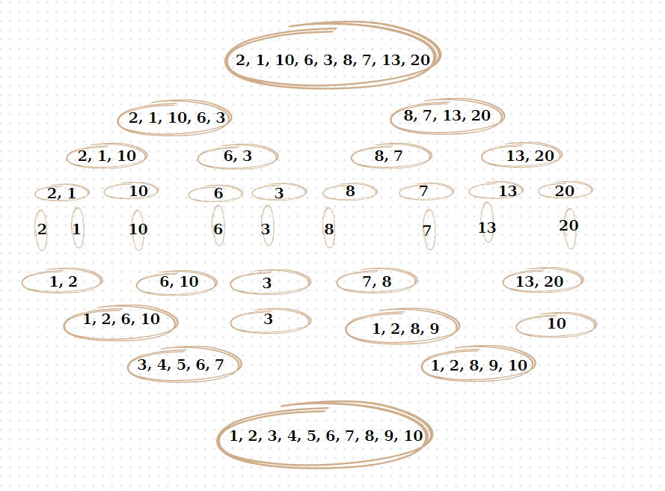

* Quick sort

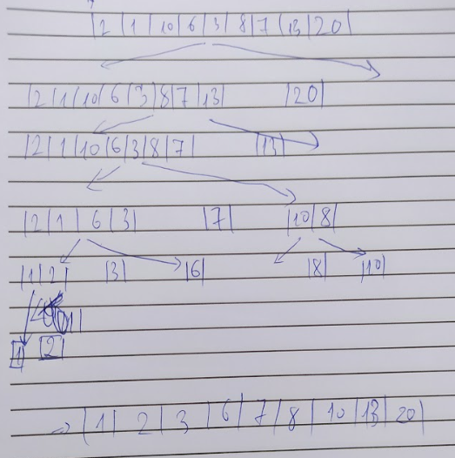

* Heap sort

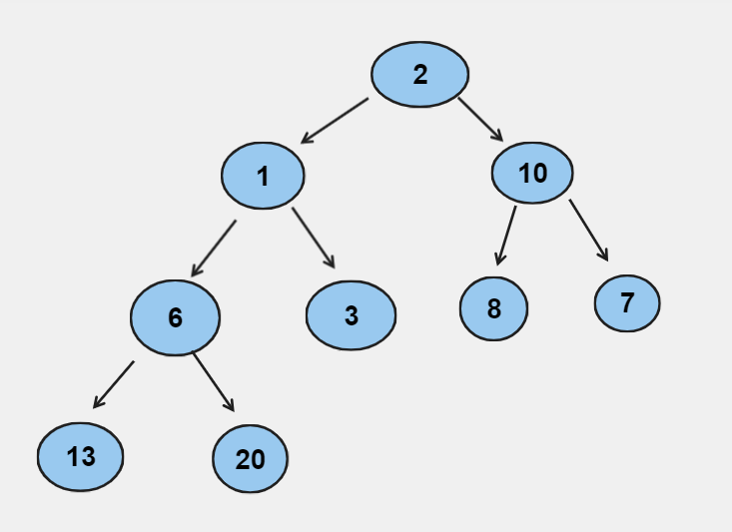

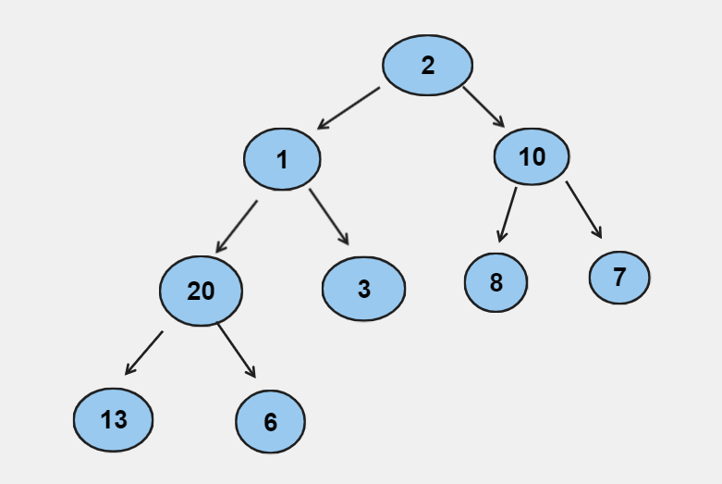

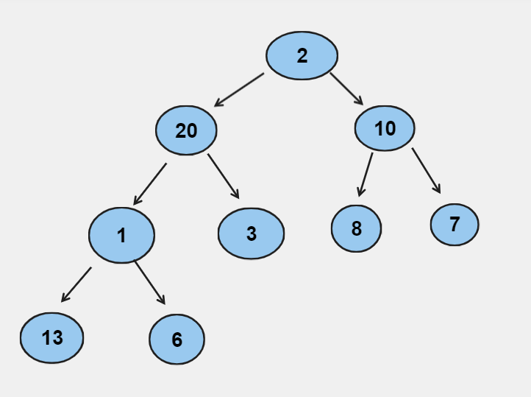

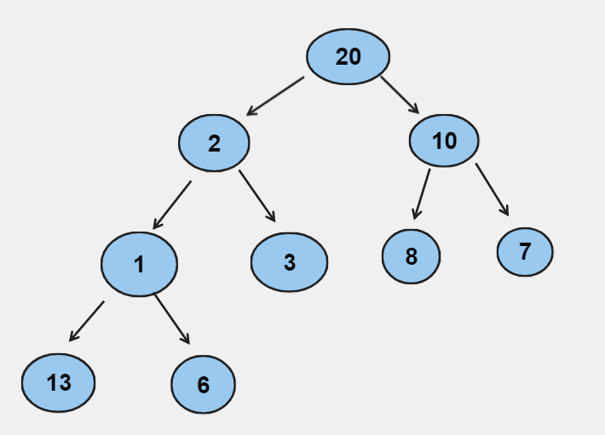

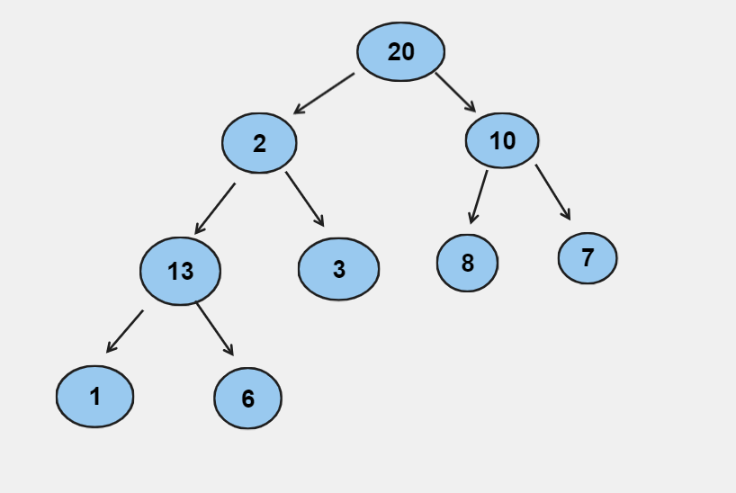

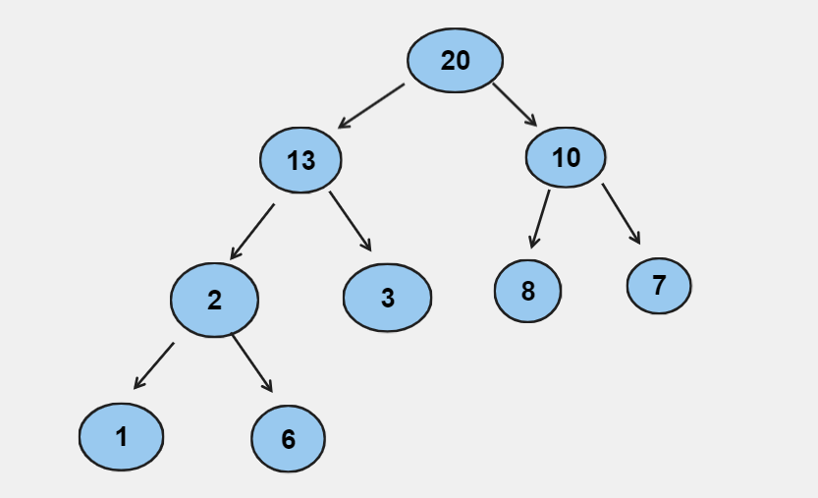

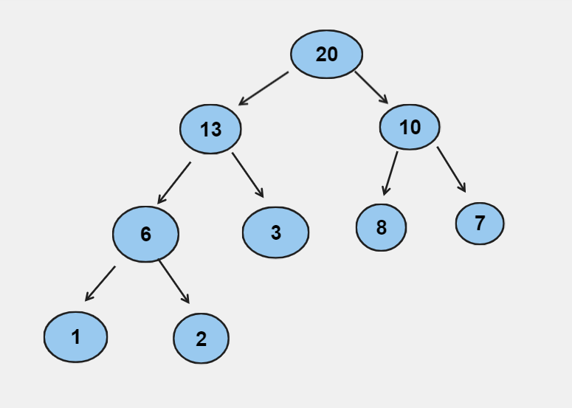

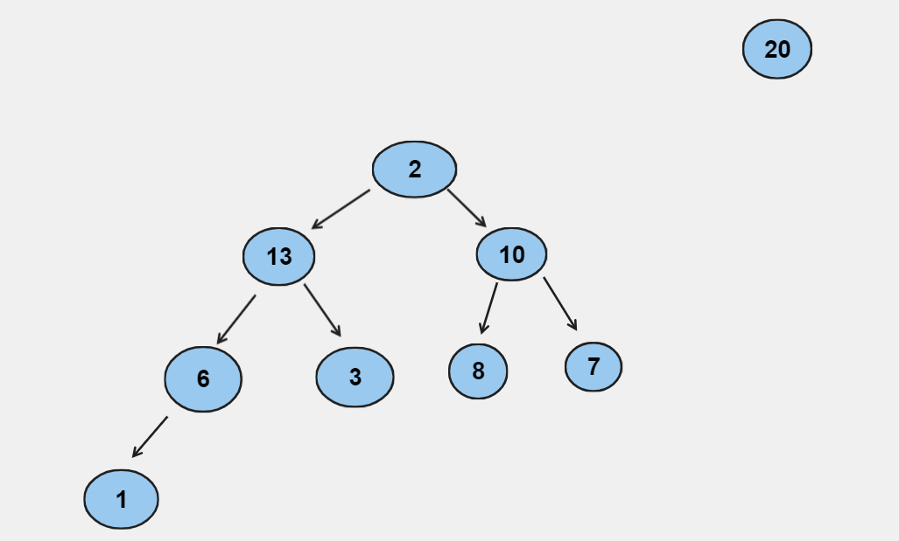

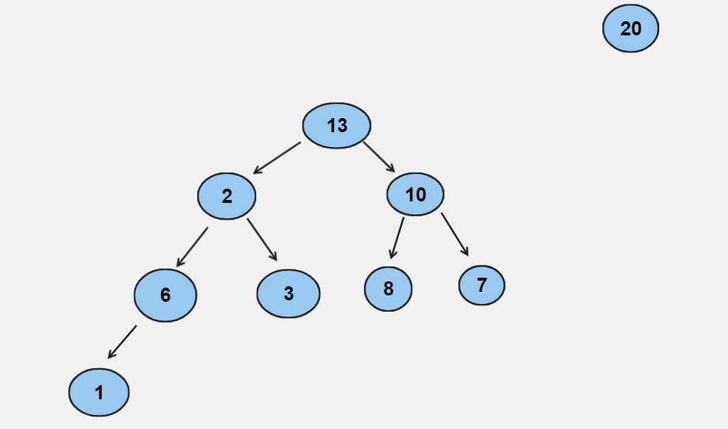

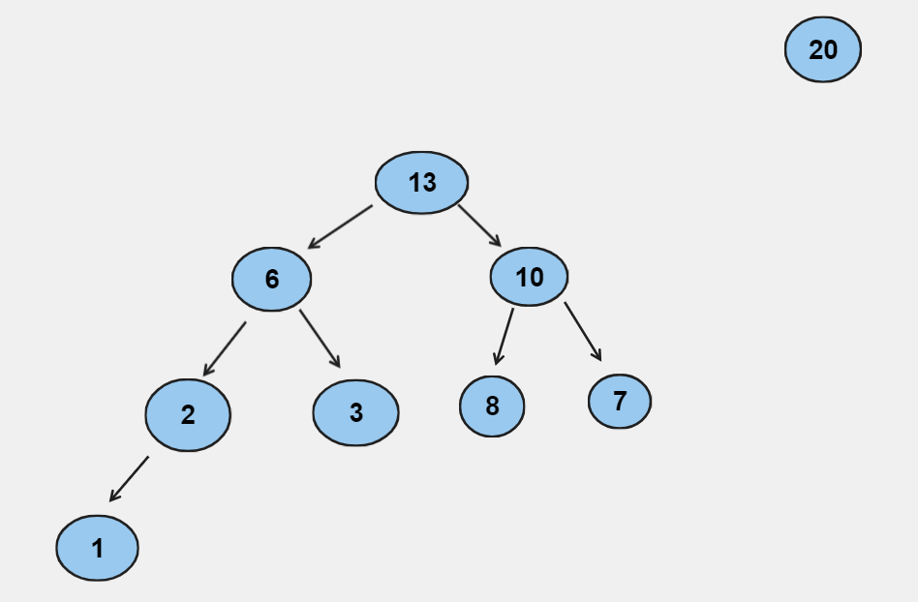

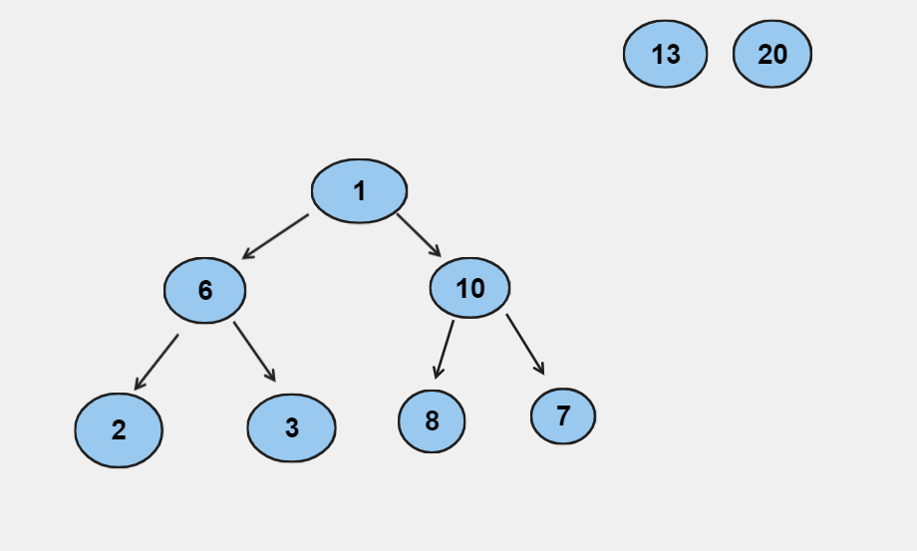

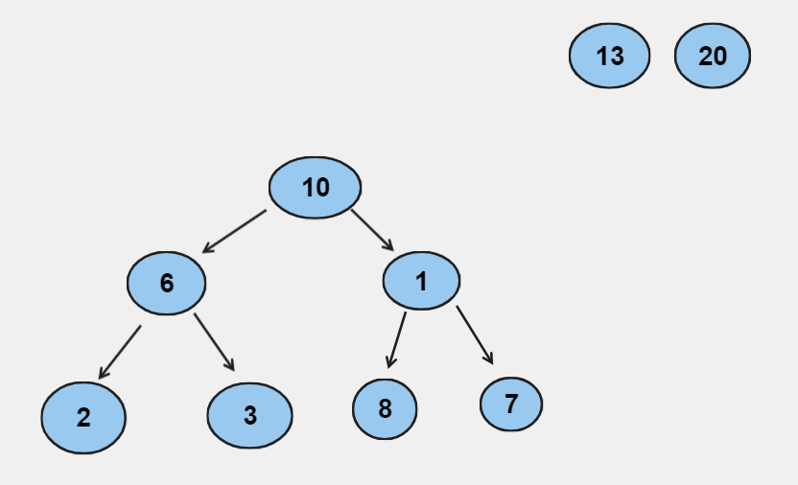

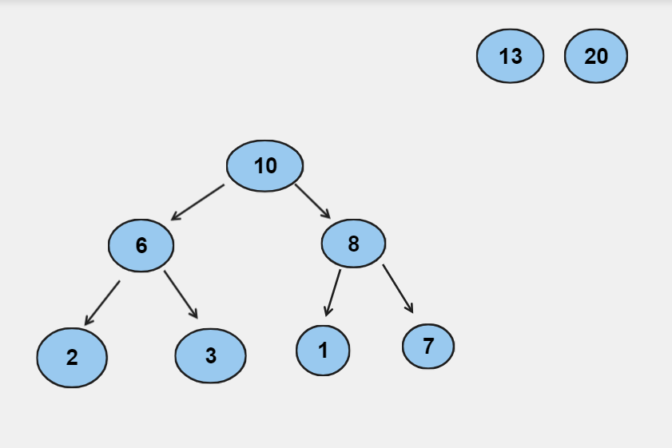

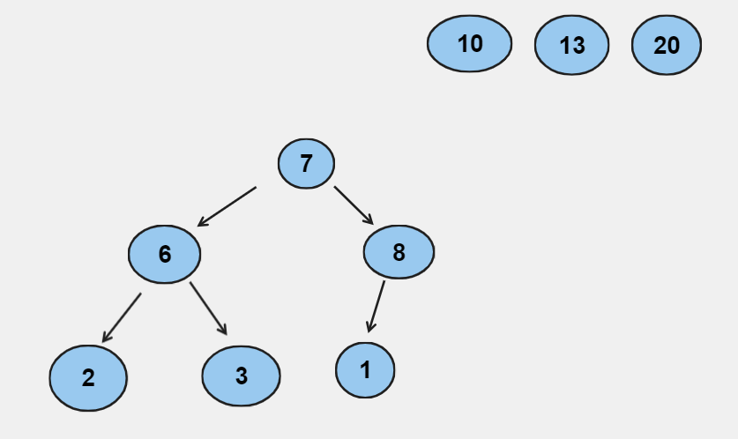

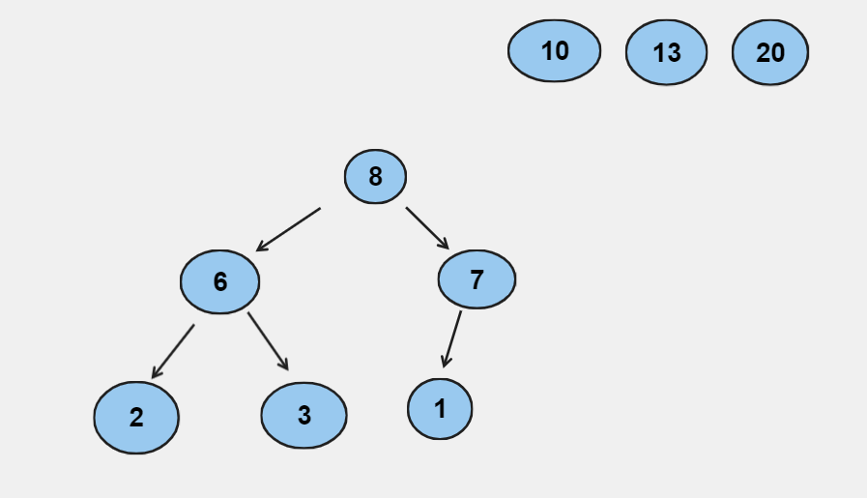

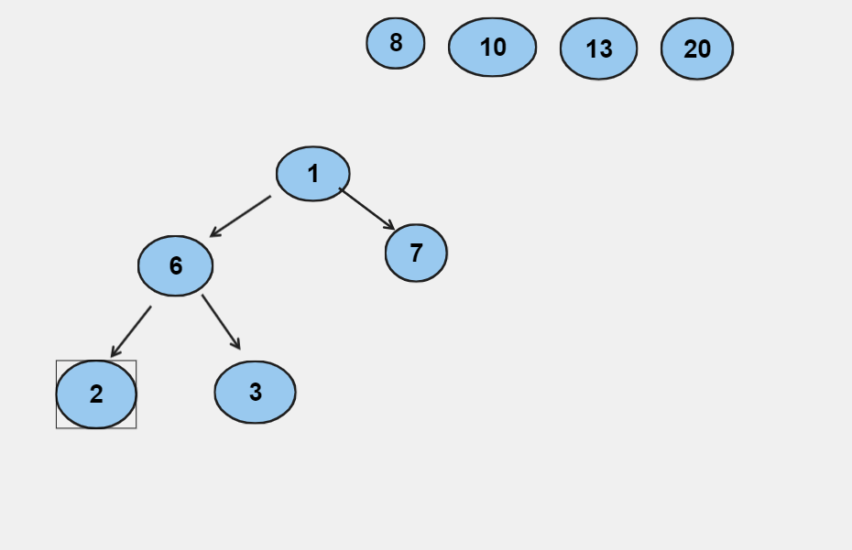

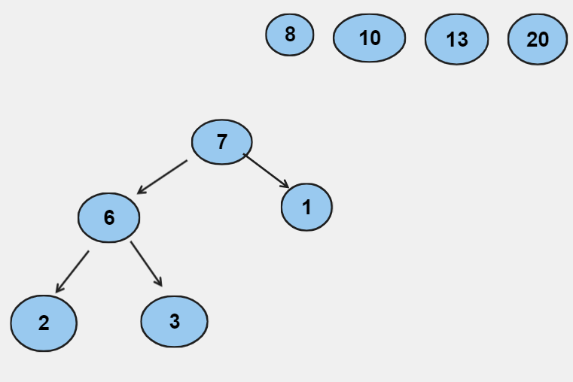

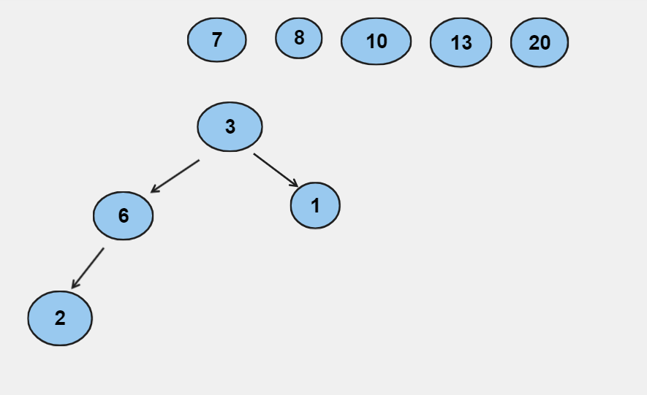

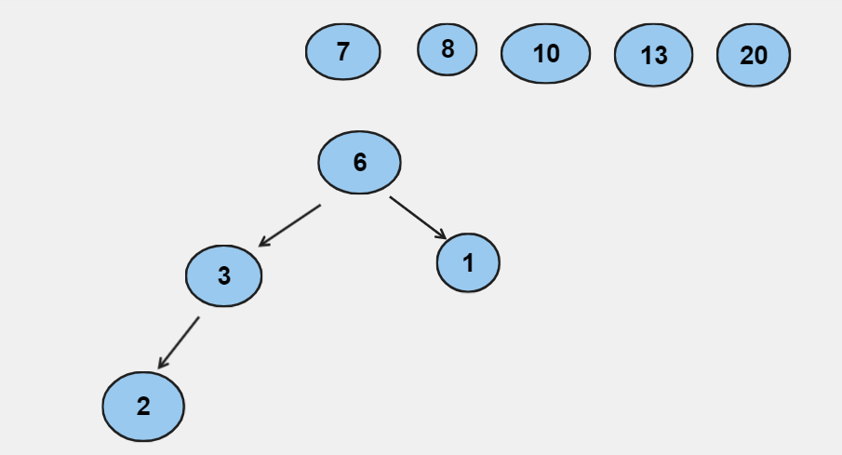

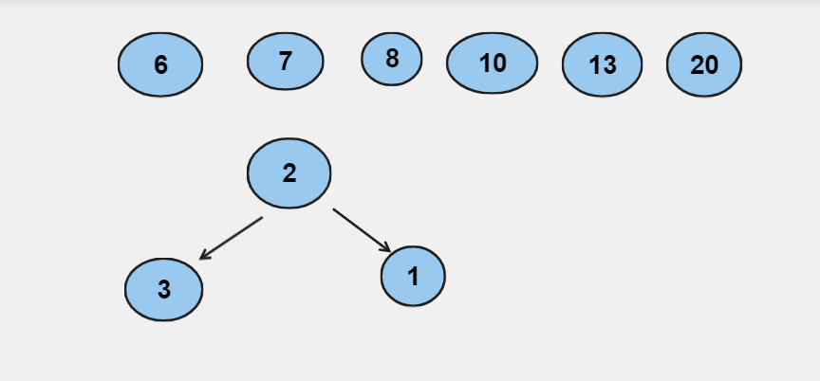

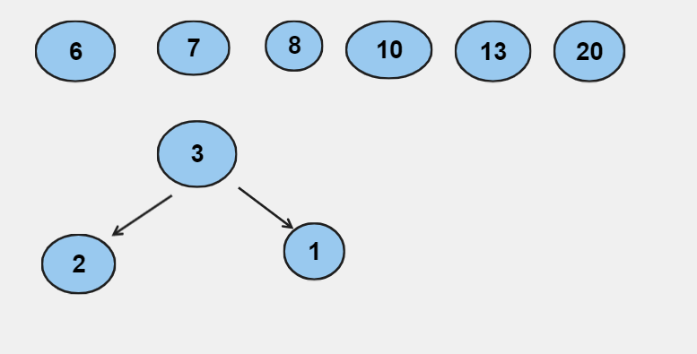

\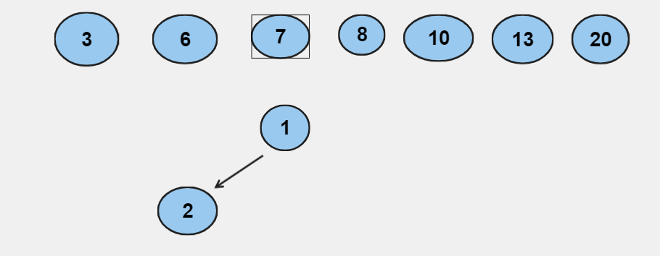

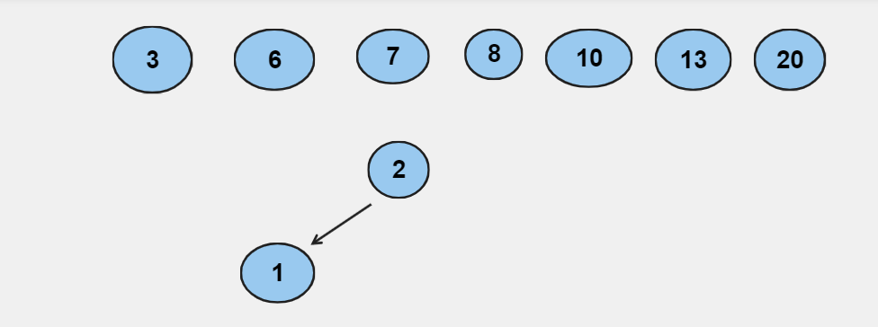

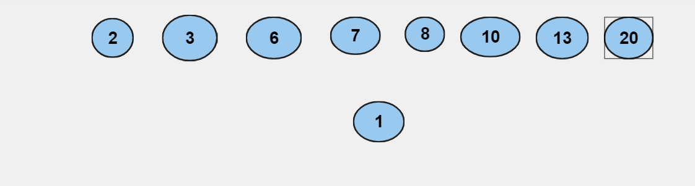

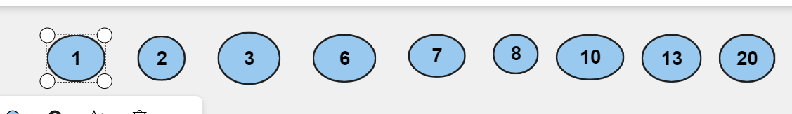

* Radix sort : 2, 1, 10, 6, 3, 8, 7, 13, 20

10, 20, 1, 2, 3, 13, 6, 7, 8

1, 2, 3, 6, 7, 8, 10, 13, 20

1. Same question for these lists:

* 1, 2, 3, 4, 5, 6, 7, 8, 9, 10
* Selection sort:

1, 2, 3, 4, 5, 6, 7, 8, 9, 10

1, 2, 3, 4, 5, 6, 7, 8, 9, 10

1, 2, 3, 4, 5, 6, 7, 8, 9, 10

1, 2, 3, 4, 5, 6, 7, 8, 9, 10

1, 2, 3, 4, 5, 6, 7, 8, 9, 10

1, 2, 3, 4, 5, 6, 7, 8, 9, 10

1, 2, 3, 4, 5, 6, 7, 8, 9, 10

1, 2, 3, 4, 5, 6, 7, 8, 9, 10

1, 2, 3, 4, 5, 6, 7, 8, 9, 10

Insertion sort:

1, 2, 3, 4, 5, 6, 7, 8, 9, 10

1, 2, 3, 4, 5, 6, 7, 8, 9, 10

1, 2, 3, 4, 5, 6, 7, 8, 9, 10

1, 2, 3, 4, 5, 6, 7, 8, 9, 10

1, 2, 3, 4, 5, 6, 7, 8, 9, 10

1, 2, 3, 4, 5, 6, 7, 8, 9, 10

1, 2, 3, 4, 5, 6, 7, 8, 9, 10

1, 2, 3, 4, 5, 6, 7, 8, 9, 10

1, 2, 3, 4, 5, 6, 7, 8, 9, 10

1, 2, 3, 4, 5, 6, 7, 8, 9, 10

Bubble sort:

1, 2, 3, 4, 5, 6, 7, 8, 9, 10

1, 2, 3, 4, 5, 6, 7, 8, 9, 10

1, 2, 3, 4, 5, 6, 7, 8, 9, 10

1, 2, 3, 4, 5, 6, 7, 8, 9, 10

1, 2, 3, 4, 5, 6, 7, 8, 9, 10

1, 2, 3, 4, 5, 6, 7, 8, 9, 10

1, 2, 3, 4, 5, 6, 7, 8, 9, 10

1, 2, 3, 4, 5, 6, 7, 8, 9, 10

1, 2, 3, 4, 5, 6, 7, 8, 9, 10

1, 2, 3, 4, 5, 6, 7, 8, 9, 10

Quick sort:

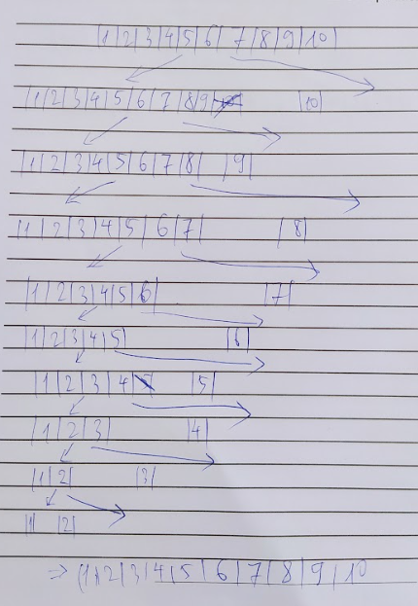

Merge sort:

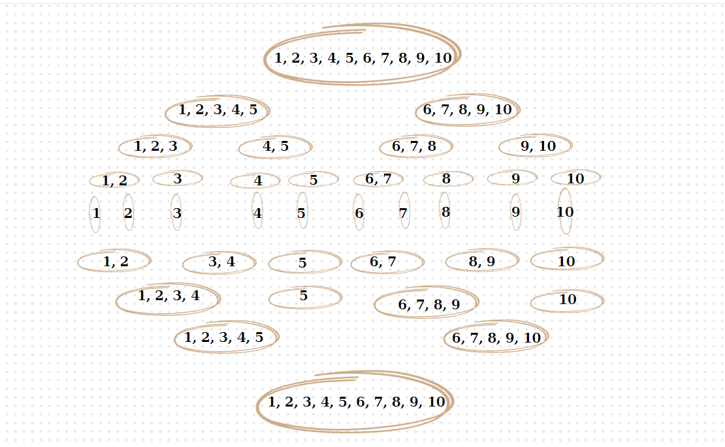

Heap sort:

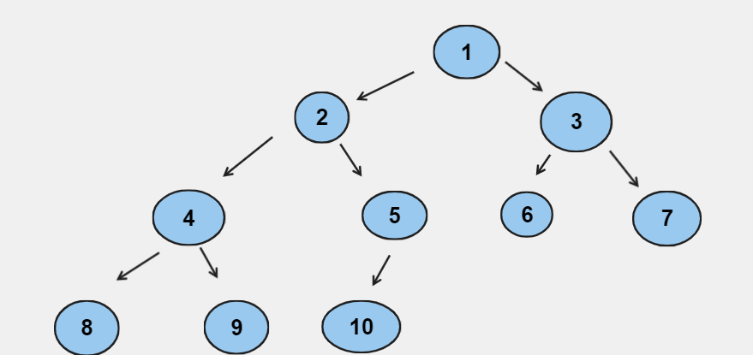

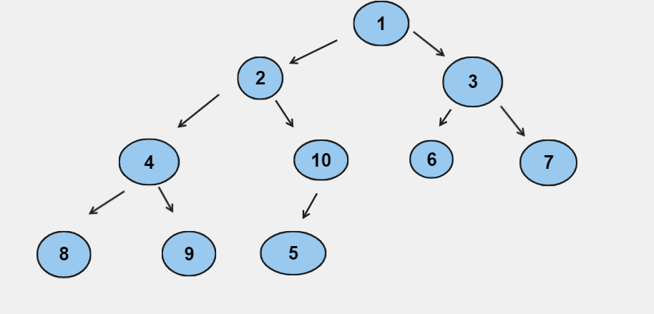

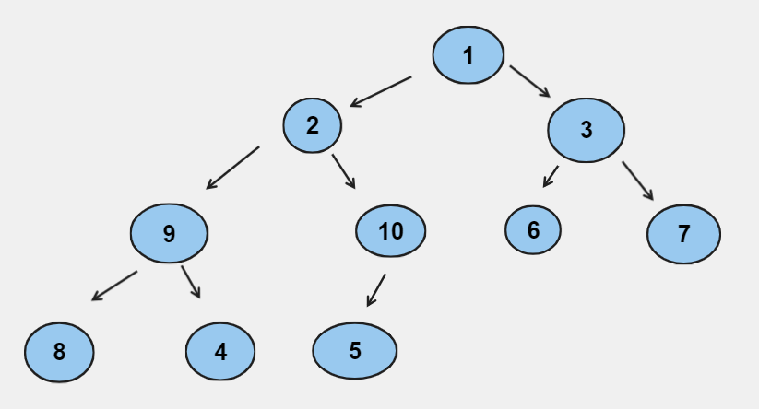

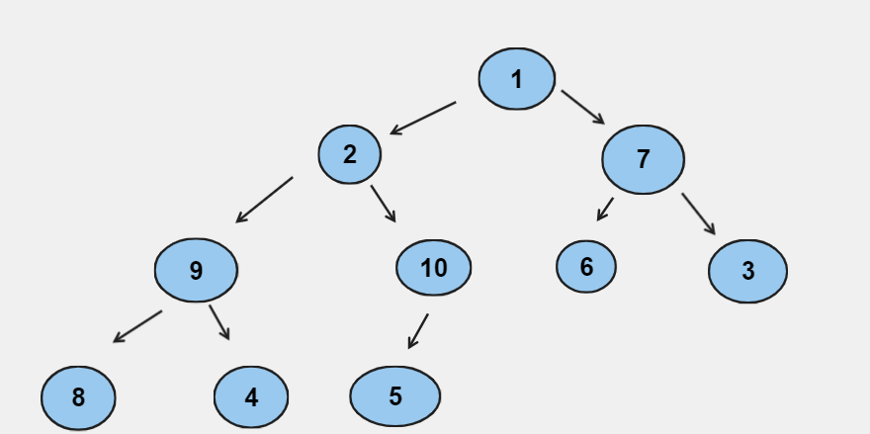

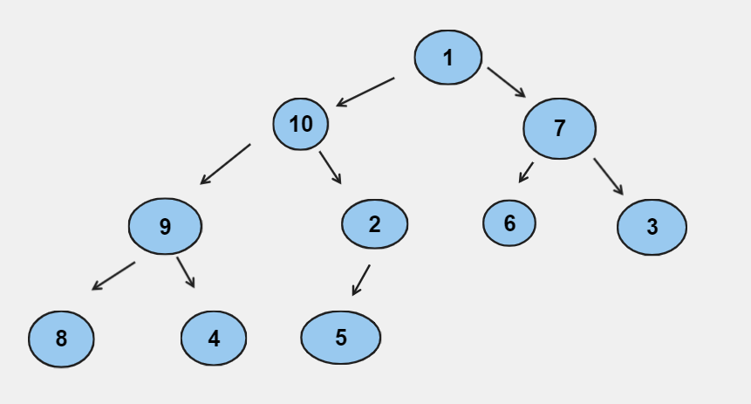

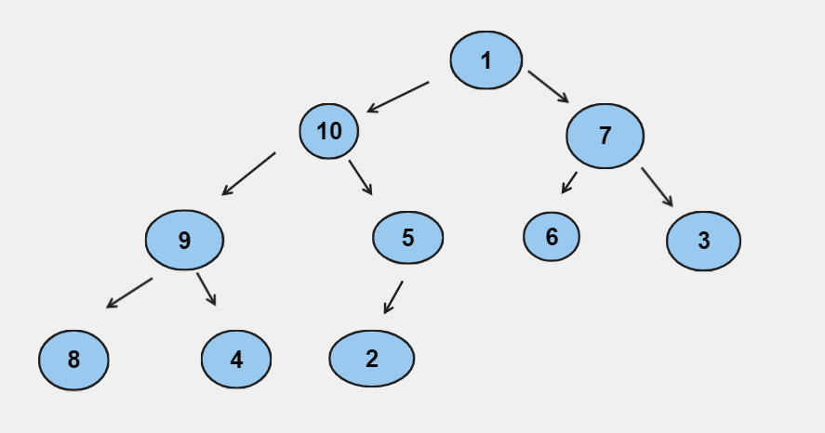

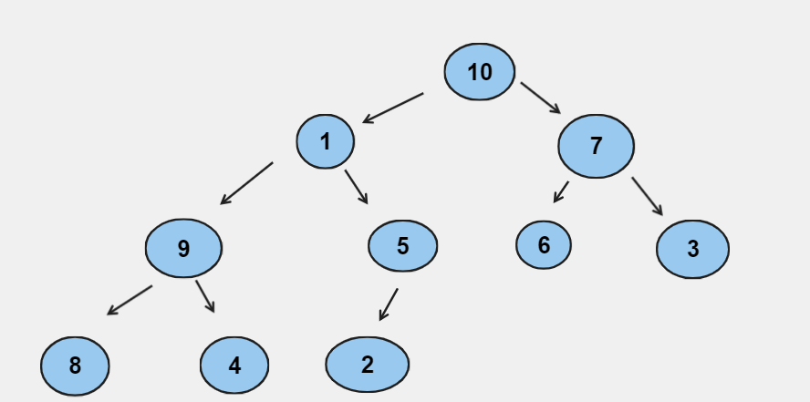

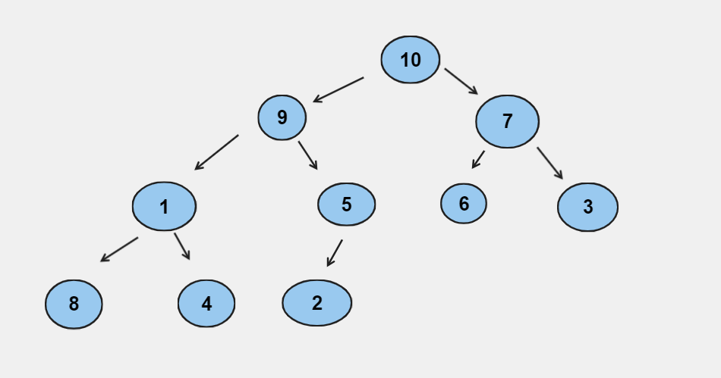

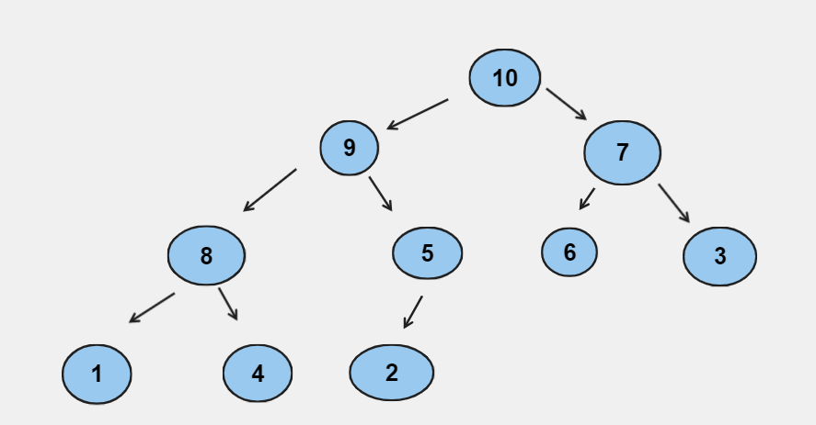

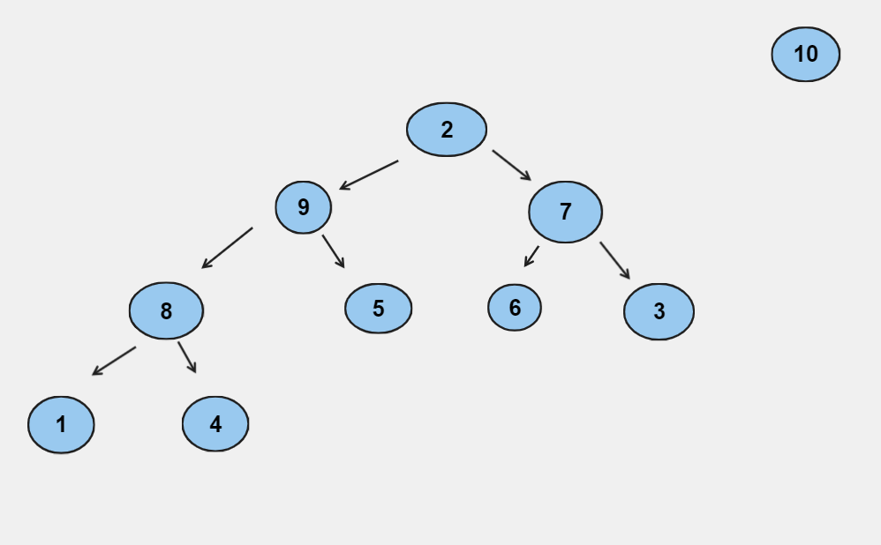

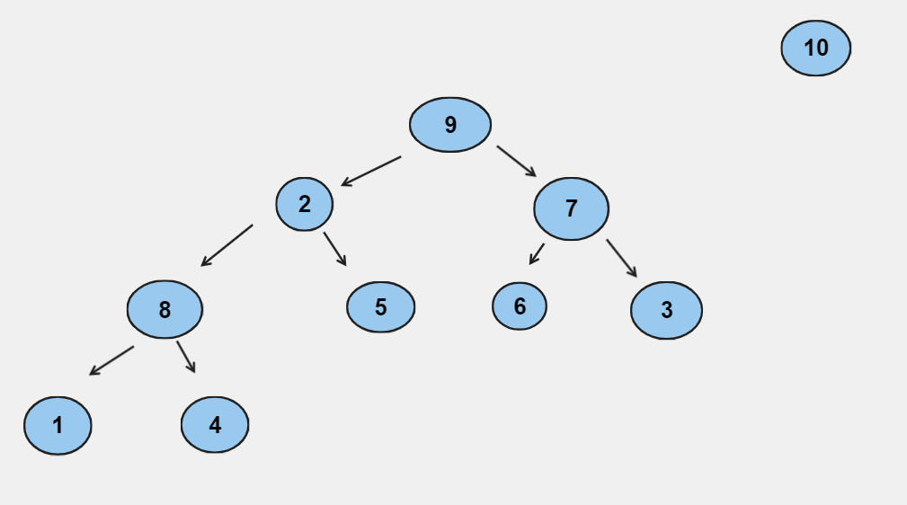

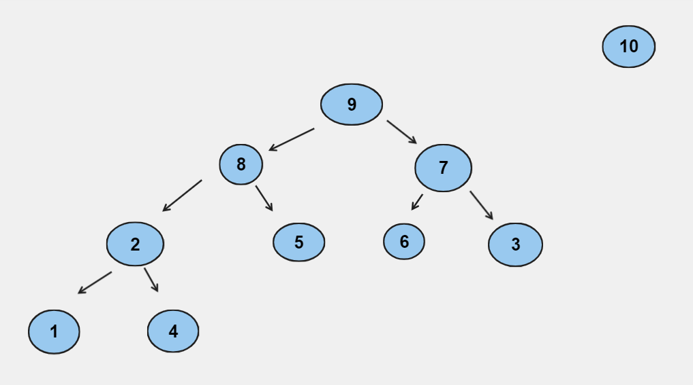

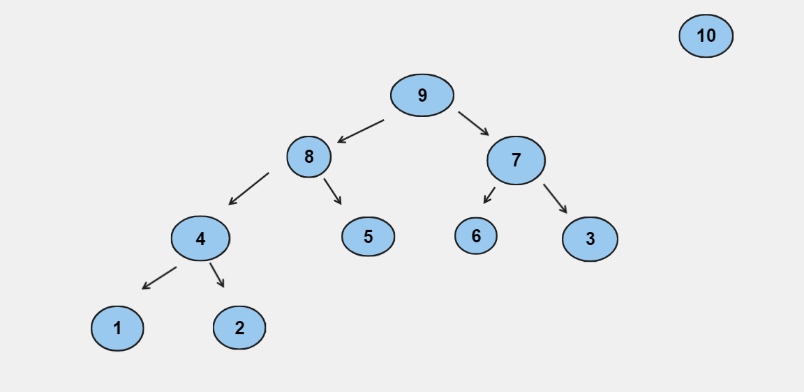

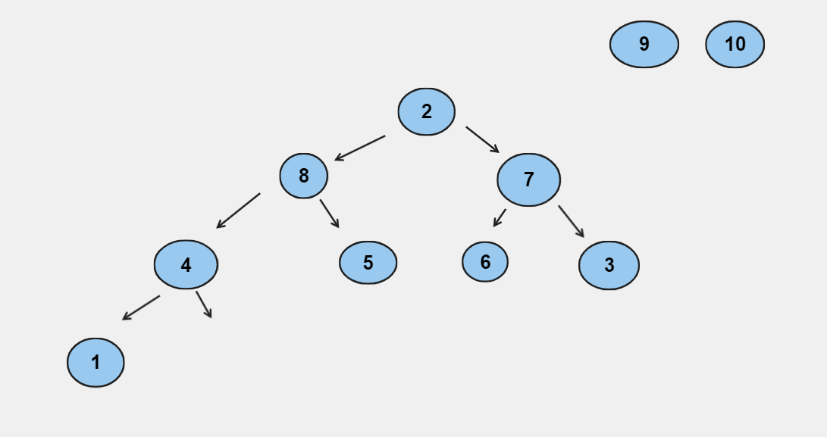

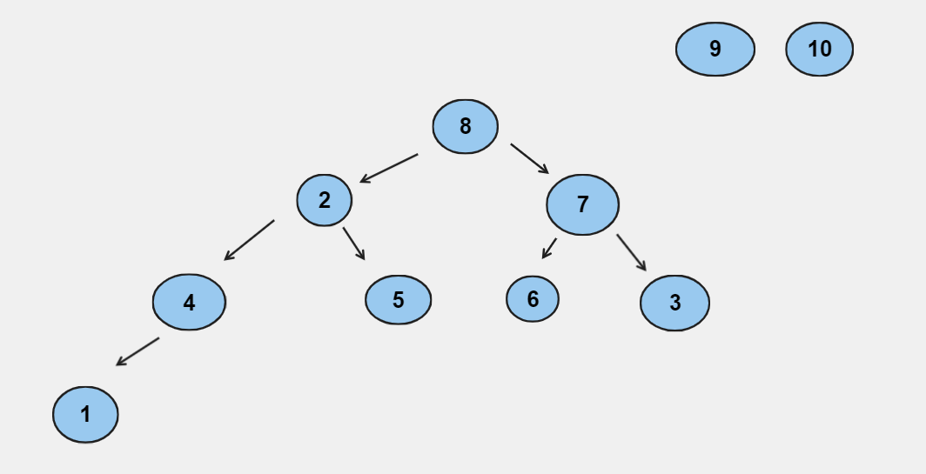

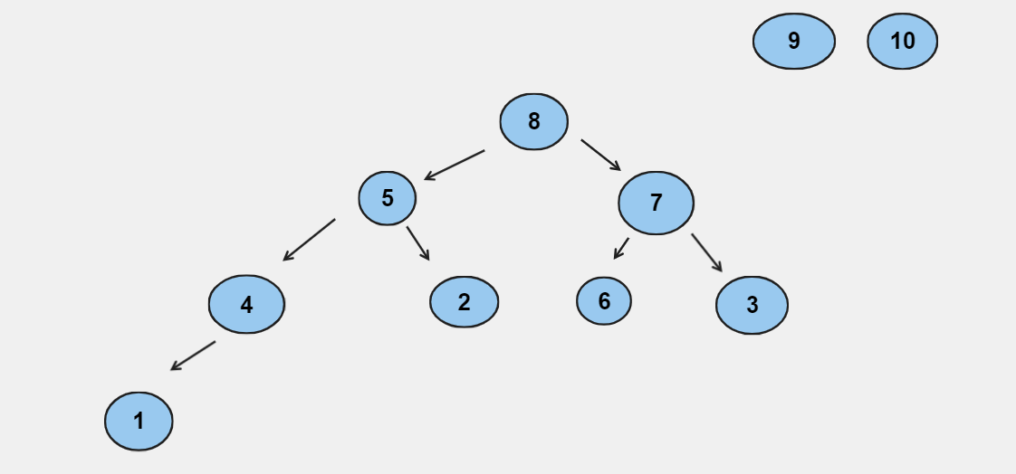

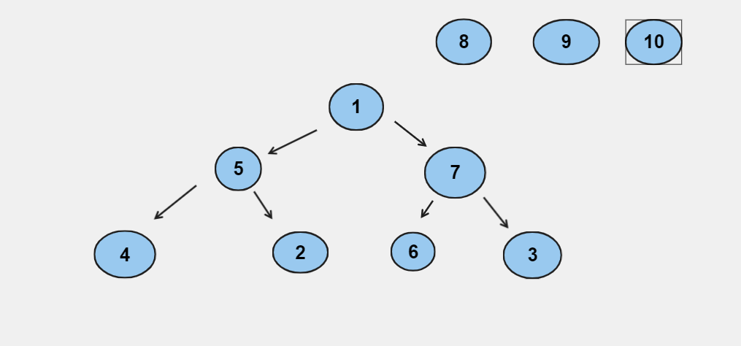

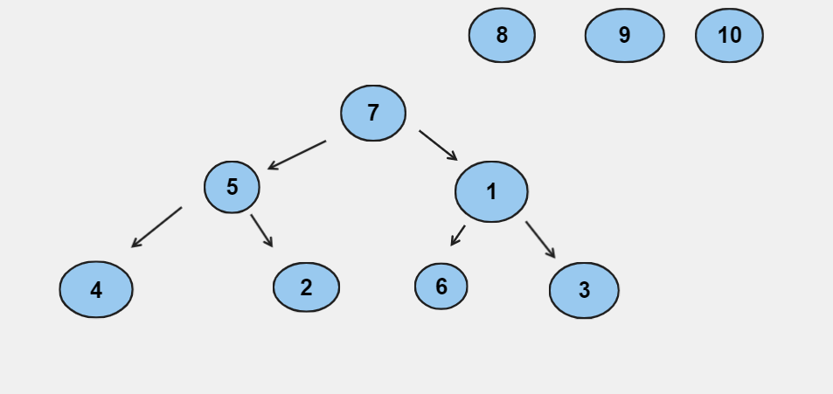

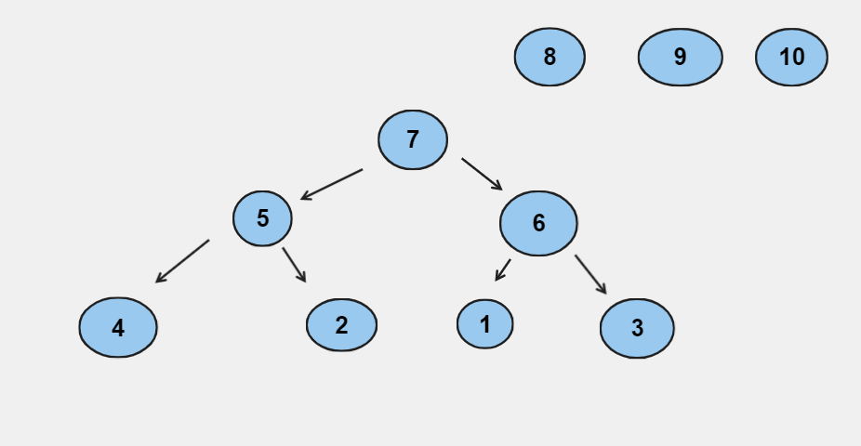

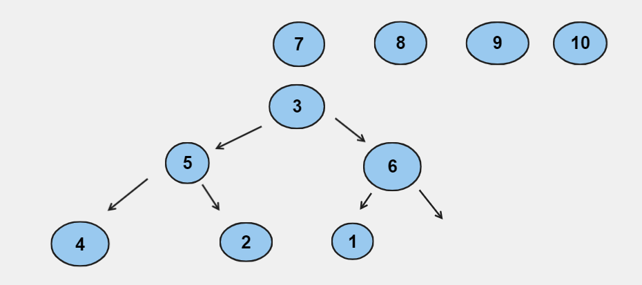

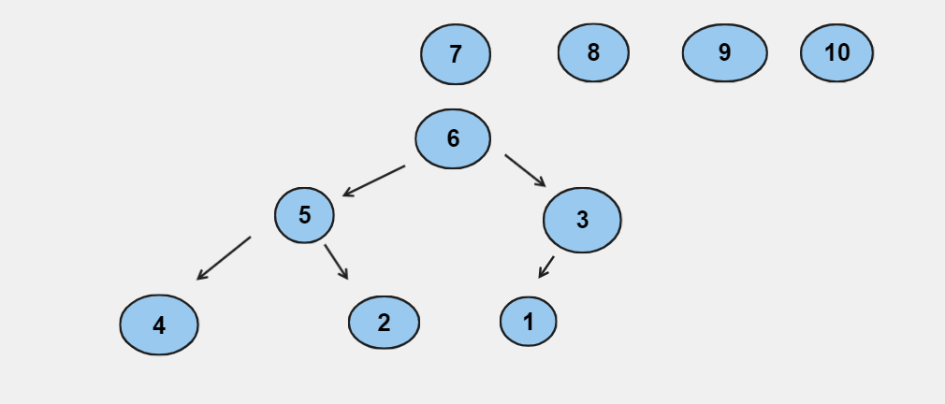

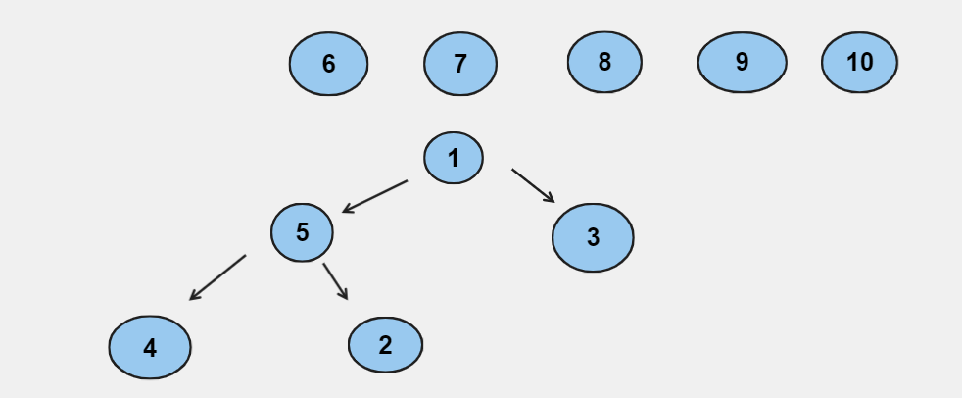

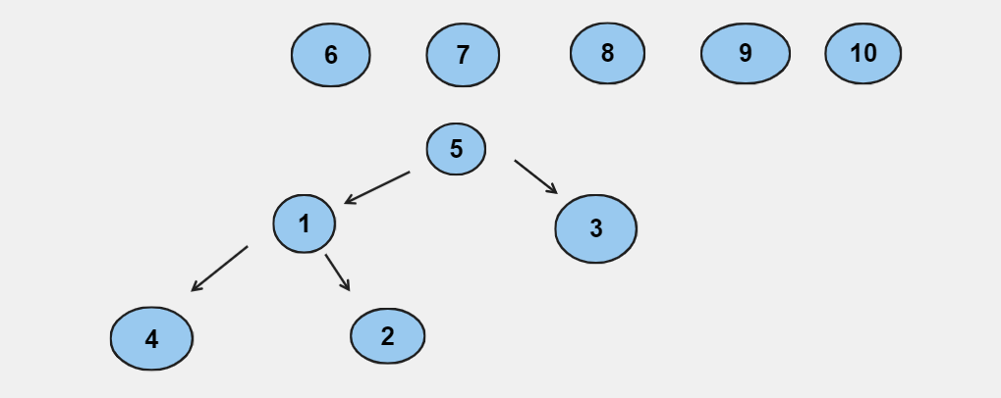

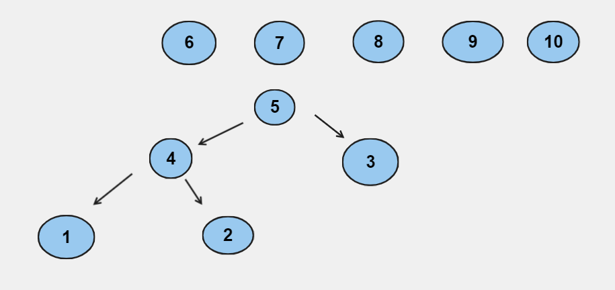

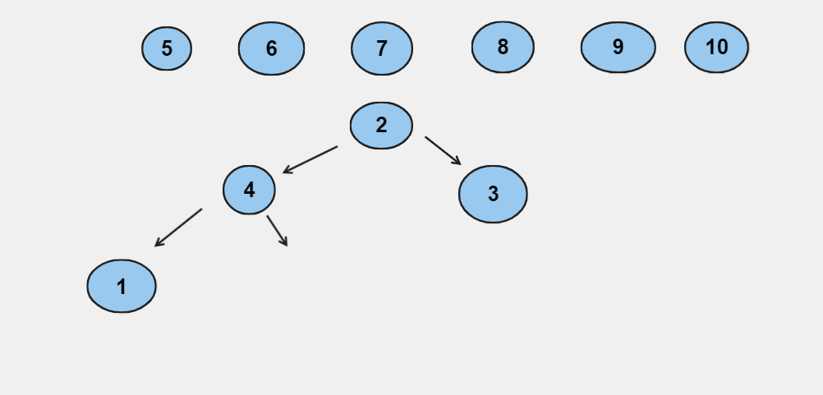

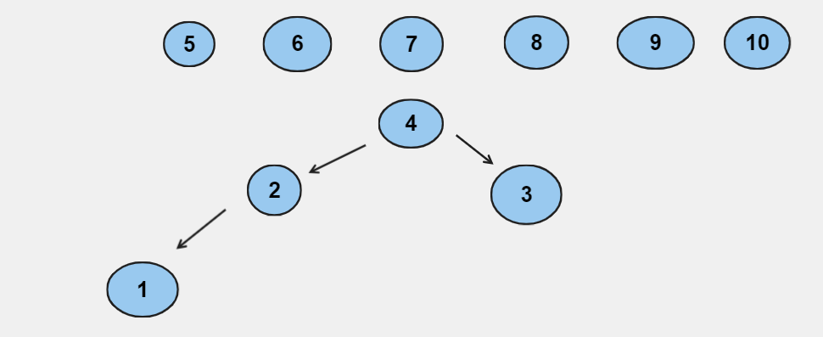

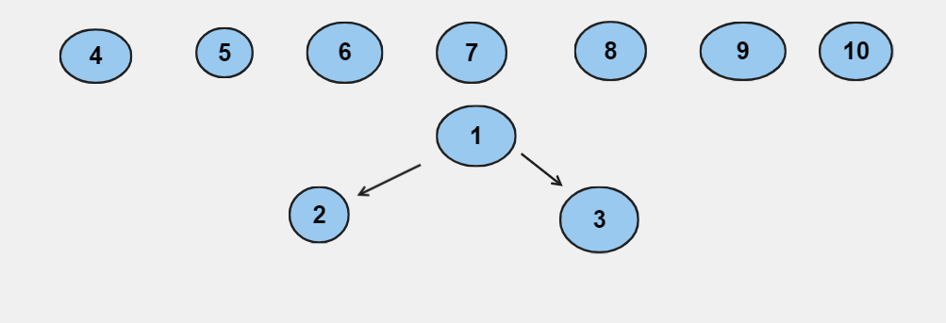

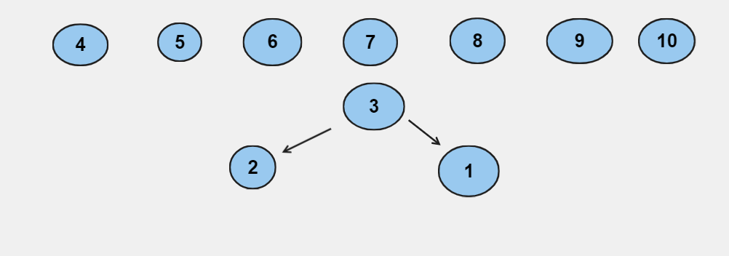

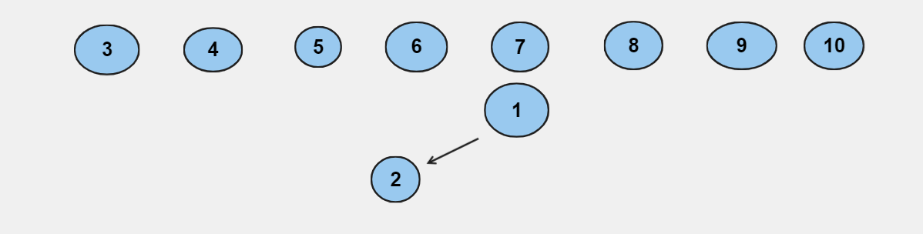

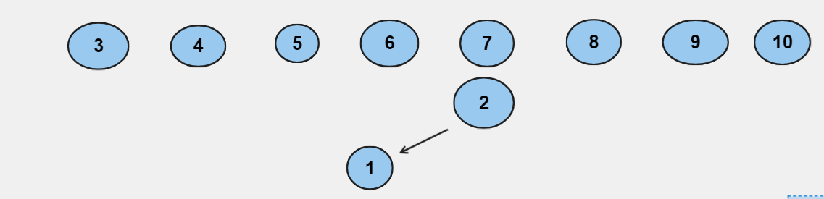

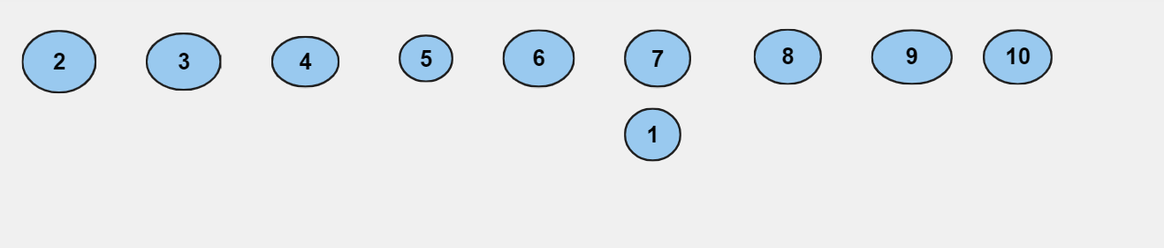

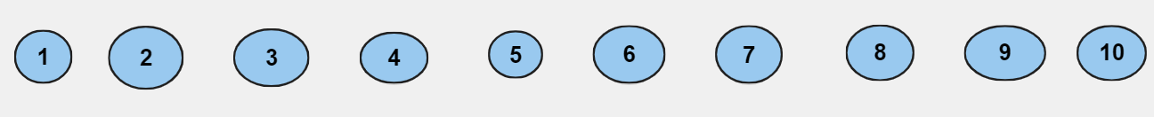

Radix sort: 1, 2, 3, 4, 5, 6, 7, 8, 9, 10

10, 1, 2, 3, 4, 5, 6, 7, 8, 9

1, 2, 3, 4, 5, 6, 7, 8, 9, 10

* 10, 9, 8, 7, 6, 5, 4, 3, 2, 1

Quick sort:

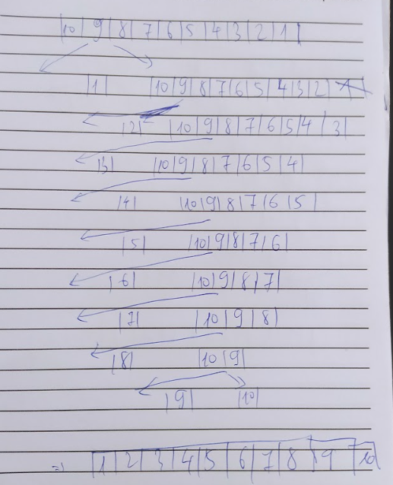

Selection sort:

1, 9, 8, 7, 6, 5, 4, 3, 2, 10

1, 2, 8, 7, 6, 5, 4, 3, 9, 10

1, 2, 3, 7, 6, 5, 4, 8, 9, 10

1, 2, 3, 4, 6, 5, 7, 8, 9, 10

1, 2, 3, 4, 5, 6, 7, 8, 9, 10

Insertion sort:

9, 10, 8, 7, 6, 5, 4, 3, 2, 1

8, 9, 10, 7, 6, 5, 4, 3, 2, 1

7, 8, 9, 10, 6, 5, 4, 3, 2, 1

6, 7, 8, 9, 10, 5, 4, 3, 2, 1

5, 6, 7, 8, 9, 10, 4, 3, 2, 1

4, 5, 6, 7, 8, 9, 10, 3, 2, 1

3, 4, 5, 6, 7, 8, 9, 10, 2, 1

2, 3, 4, 5, 6, 7, 8, 9, 10, 1

1, 2, 3, 4, 5, 6, 7, 8, 9, 10

Bubble sort:

9, 8, 7, 6, 5, 4, 3, 2, 1, 10

8, 7, 6, 5, 4, 3, 2, 1, 9, 10

7, 6, 5, 4, 3, 2, 1, 8, 9, 10

6, 5, 4, 3, 2, 1, 7, 8, 9, 10

5, 4, 3, 2, 1, 6, 7, 8, 9, 10

4, 3, 2, 1, 5, 6, 7, 8, 9, 10

3, 2, 1, 4, 5, 6, 7, 8, 9, 10

2, 1, 3, 4, 5, 6, 7, 8, 9, 10

1, 2, 3, 4, 5, 6, 7, 8, 9, 10

Merge sort:

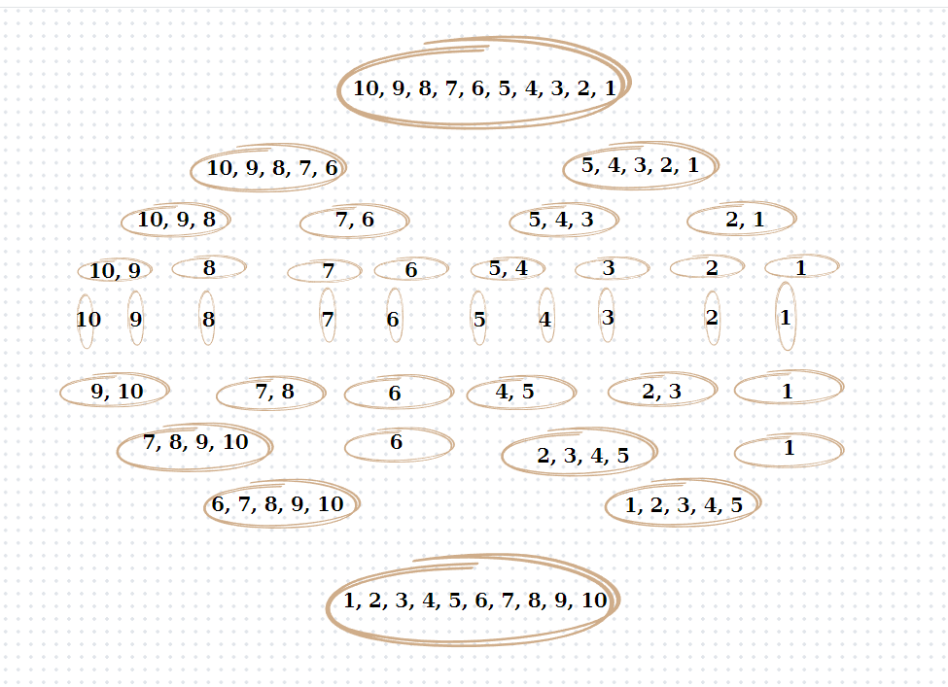

Heap sort:

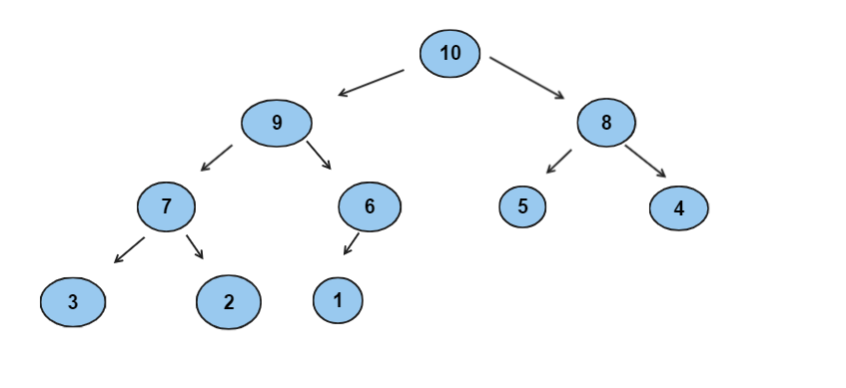

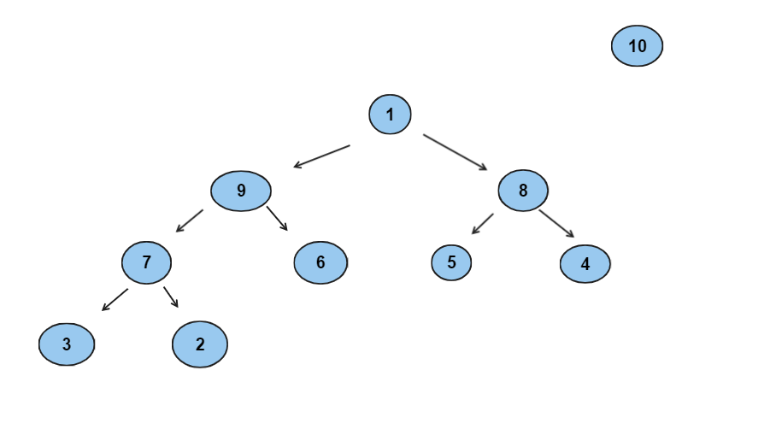

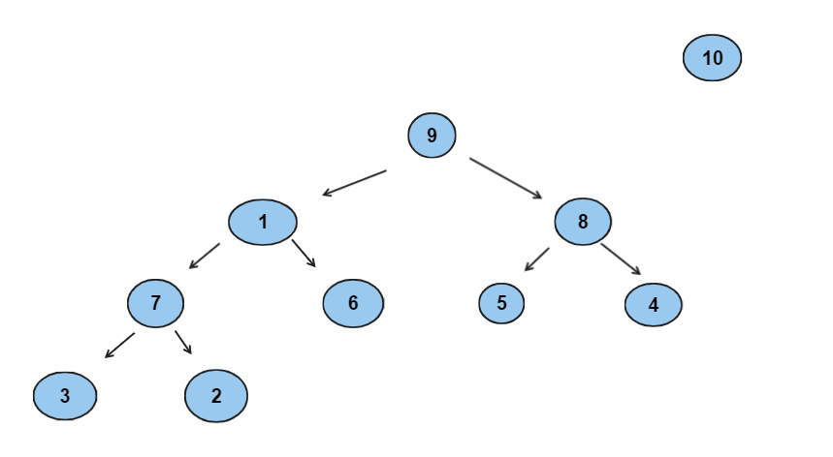

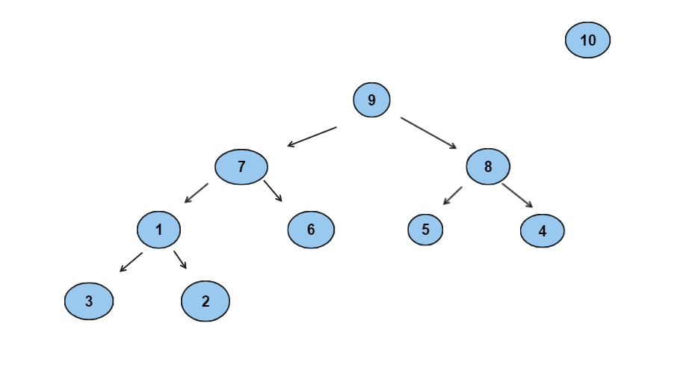

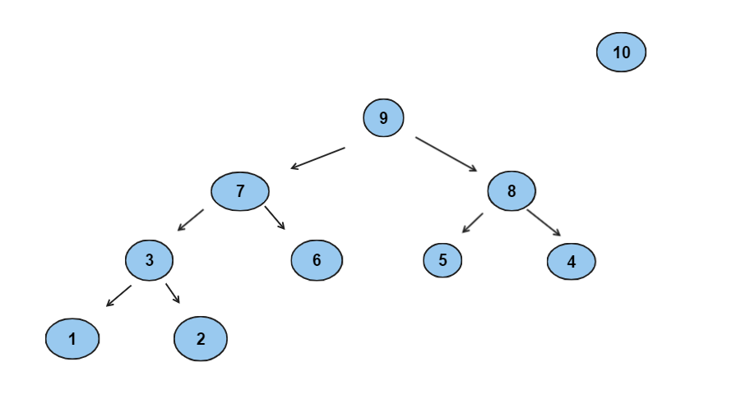

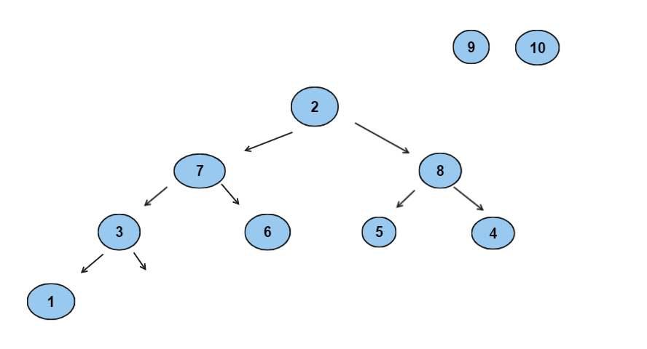

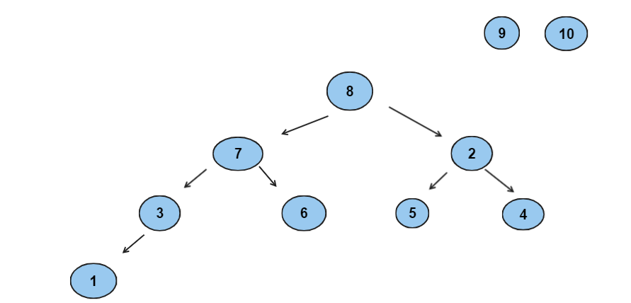

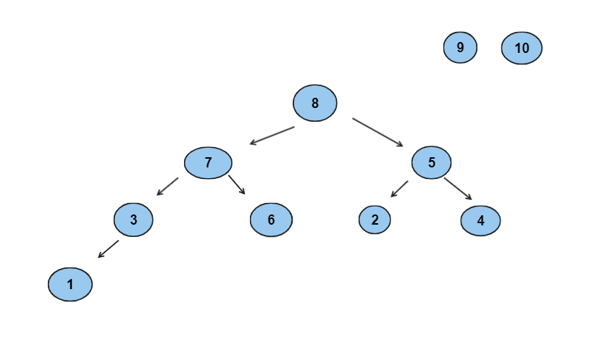

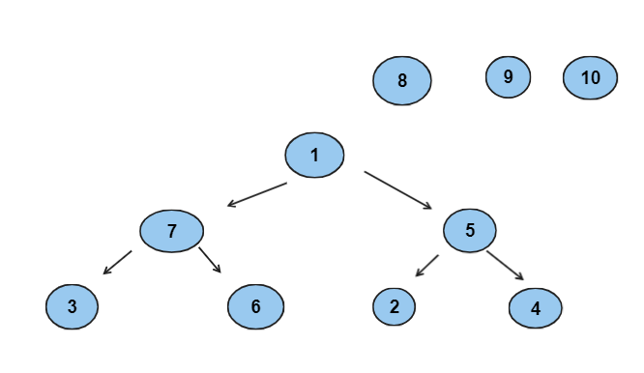

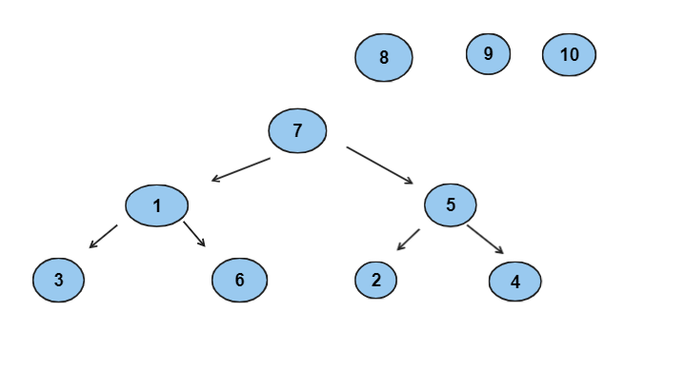

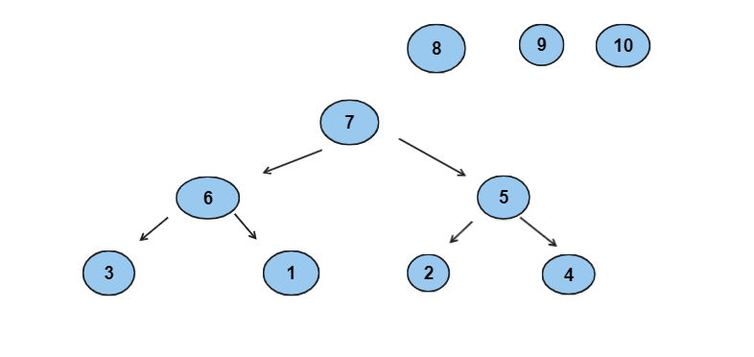

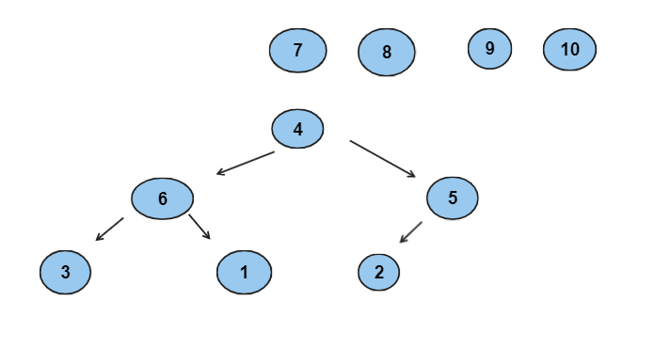

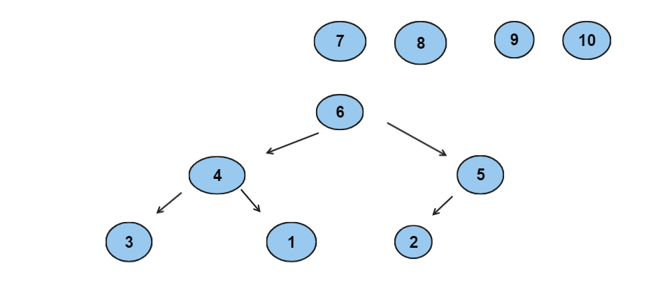

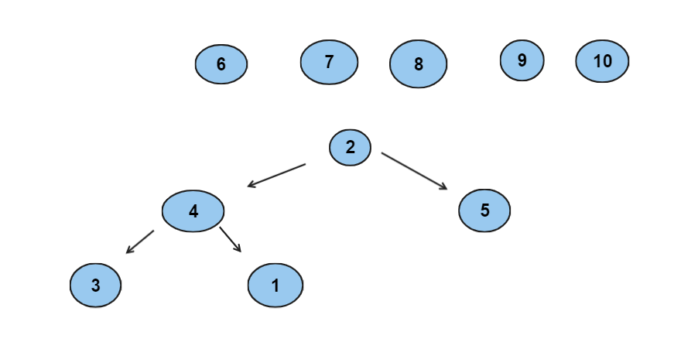

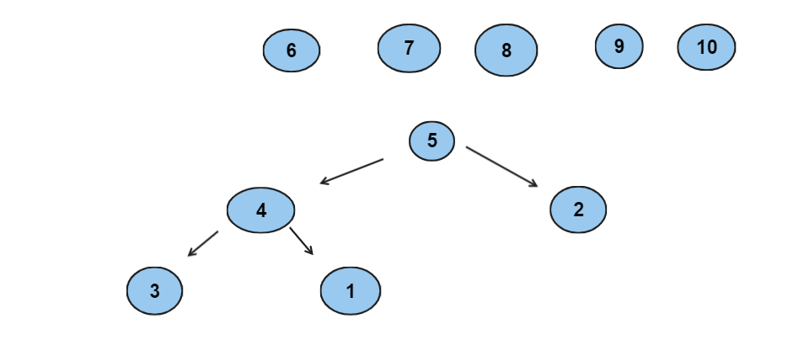

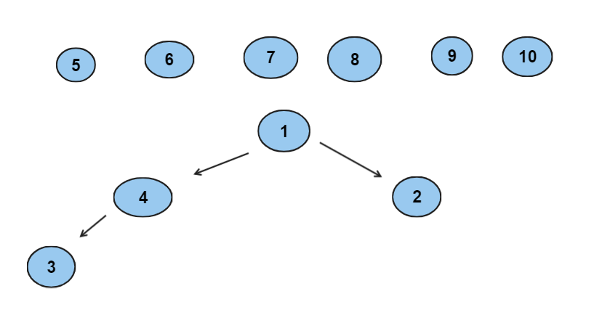

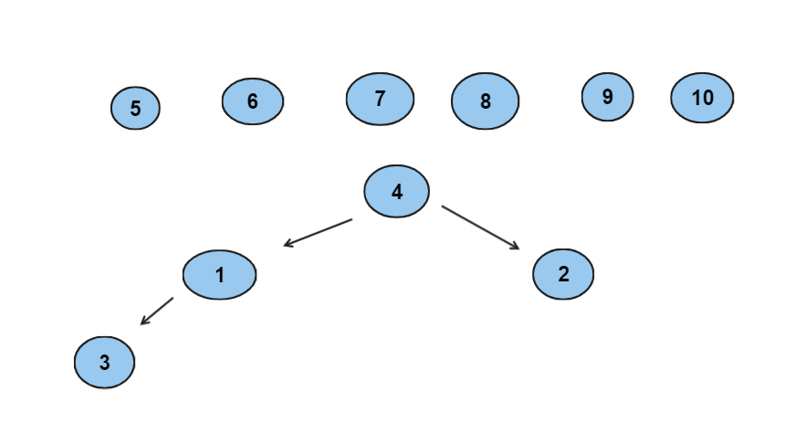

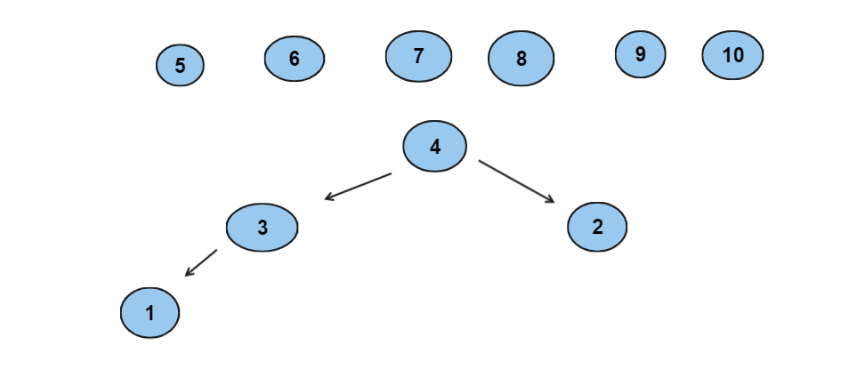

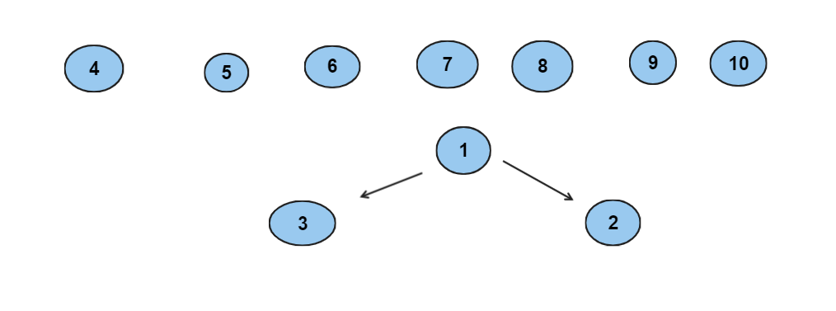

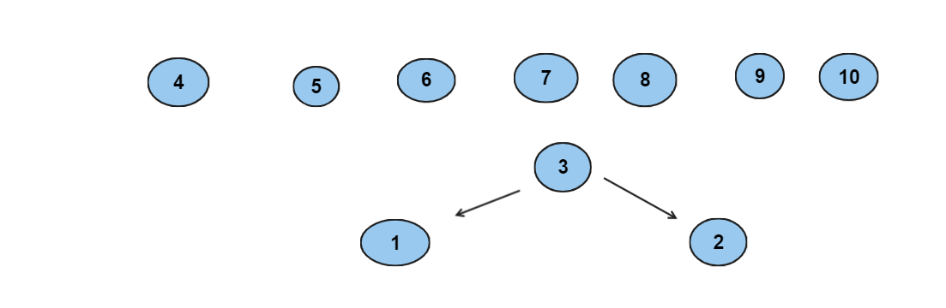

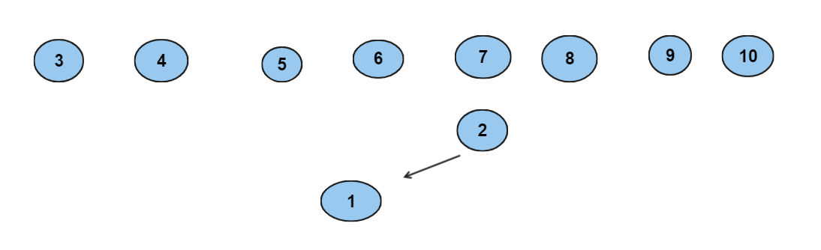

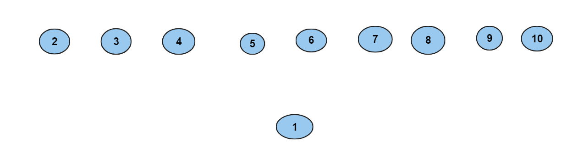

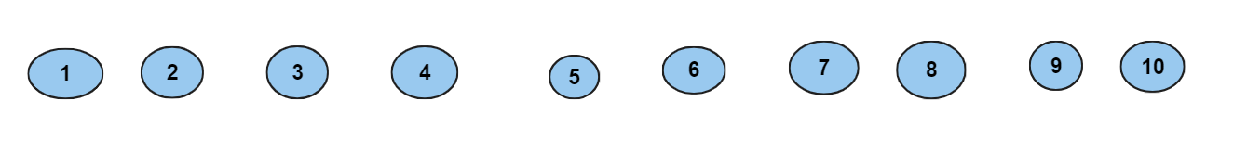

Radix sort: 10, 9, 8, 7, 6, 5, 4, 3, 2, 1

10, 1, 2, 3, 4, 5, 6, 7, 8, 9

1, 2, 3, 4, 5, 6, 7, 8, 9, 10

* 9, 10, 1, 2, 3, 4, 5, 6, 7, 8

Quick sort:

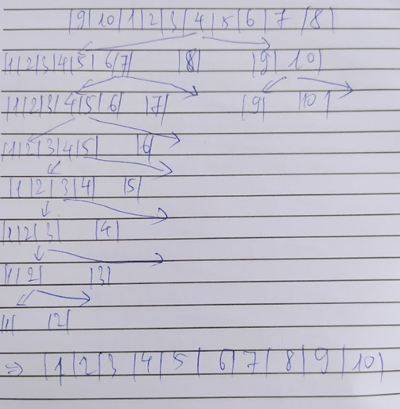

Selection sort:

1, 10, 9, 2, 3, 4, 5, 6, 7, 8

1, 2, 9, 10, 3, 4, 5, 6, 7, 8

1, 2, 3, 10, 9, 4, 5, 6, 7, 8

1, 2, 3, 4, 9, 10, 5, 6, 7, 8

1, 2, 3, 4, 5, 10, 9, 6, 7, 8

1, 2, 3, 4, 5, 6, 9, 10, 7, 8

1, 2, 3, 4, 5, 6, 7, 10, 9, 8

1, 2, 3, 4, 5, 6, 7, 8, 9, 10

Insertion sort:

1, 9, 10, 2, 3, 4, 5, 6, 7, 8

1, 2, 9, 10, 3, 4, 5, 6, 7, 8

1, 2, 3, 9, 10, 4, 5, 6, 7, 8

1, 2, 3, 4, 9, 10, 5, 6, 7, 8

1, 2, 3, 4, 5, 9, 10, 6, 7, 8

1, 2, 3, 4, 5, 6, 9, 10, 7, 8

1, 2, 3, 4, 5, 6, 7, 9, 10, 8

1, 2, 3, 4, 5, 6, 7, 8, 9, 10

Bubble sort:

9, 10, 1, 2, 3, 4, 5, 6, 7, 8

9, 1, 2, 3, 4, 5, 6, 7, 8, 10

1, 2, 3, 4, 5, 6, 7, 8, 9, 10

Merge Sort:

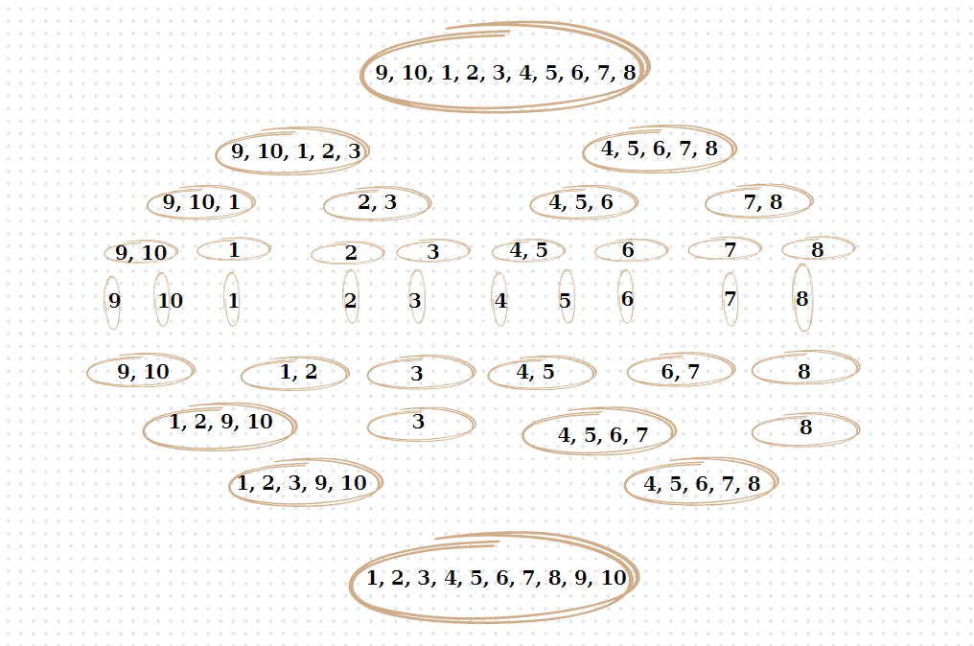

Heap sort:

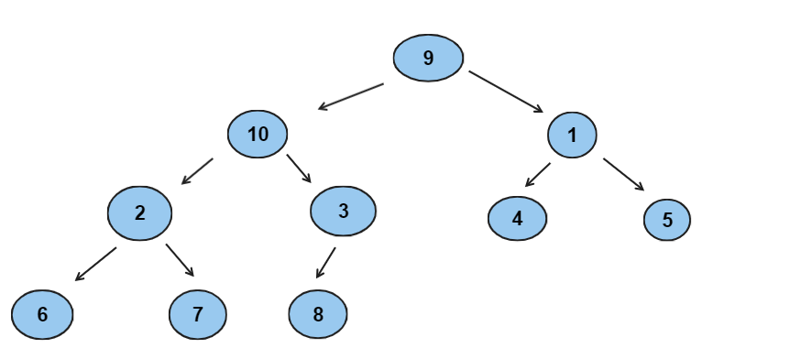

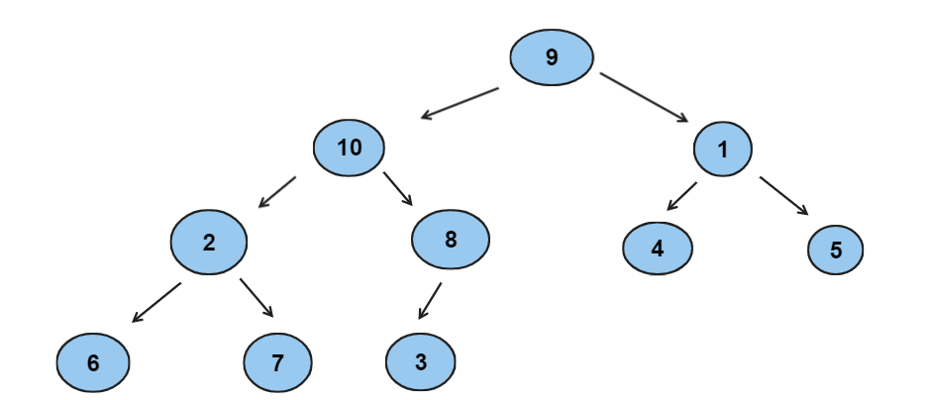

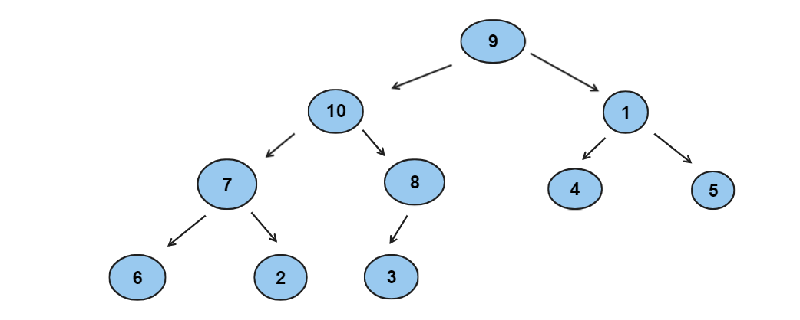

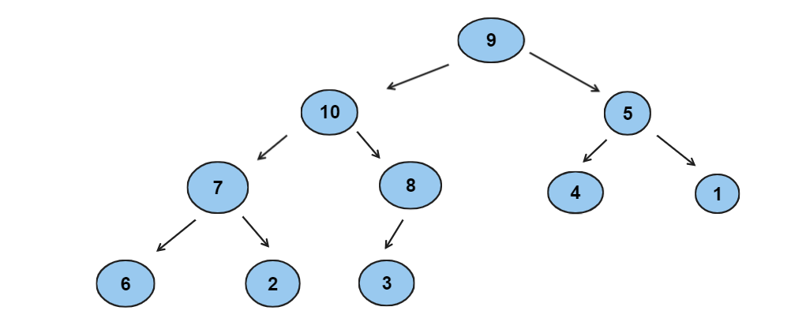

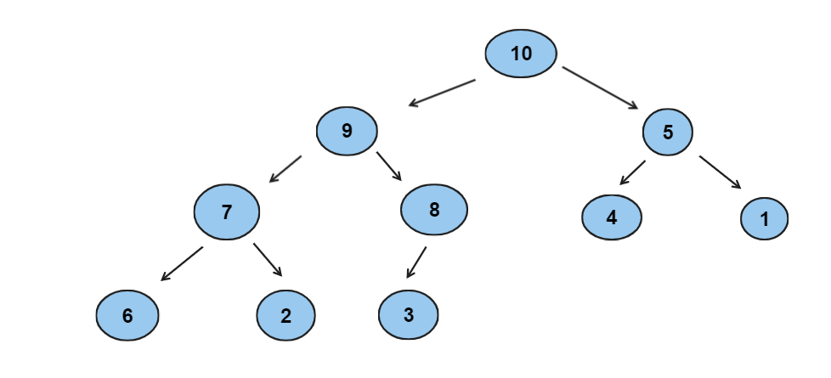

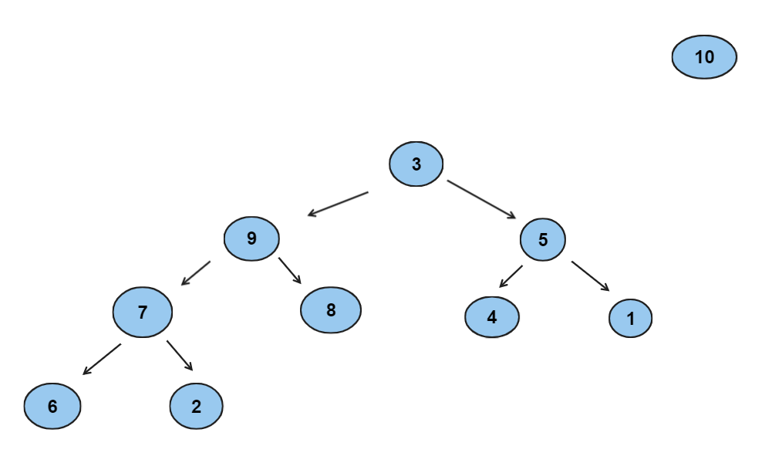

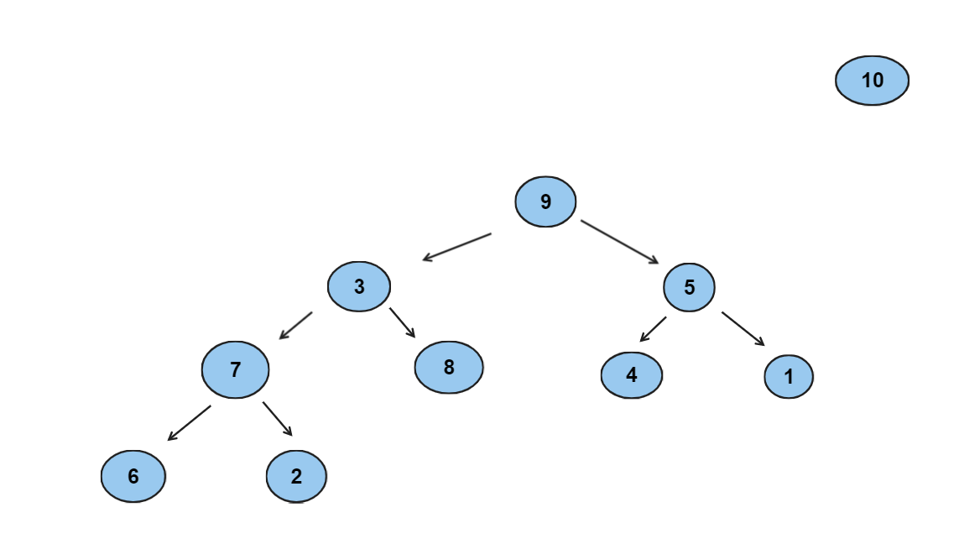

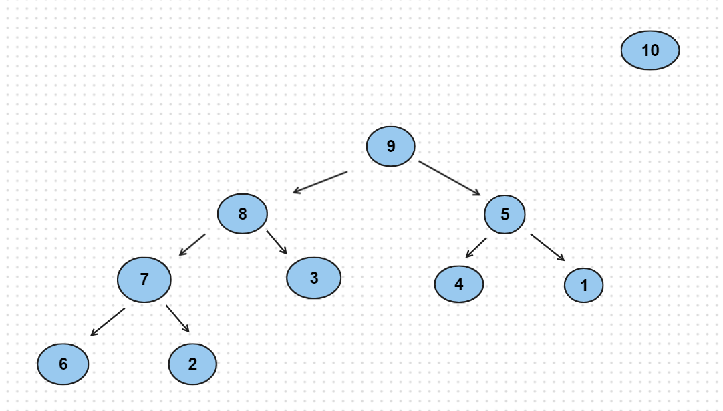

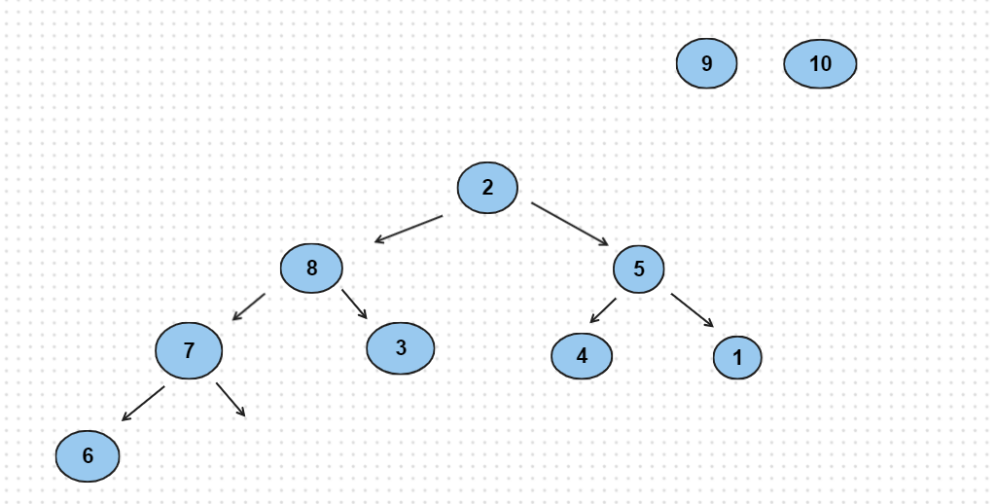

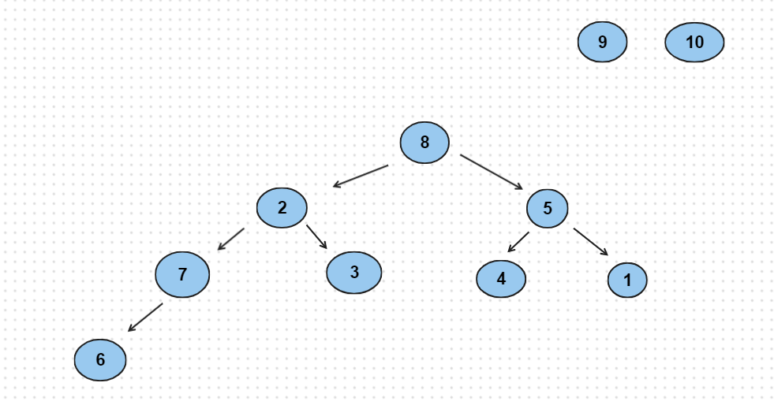

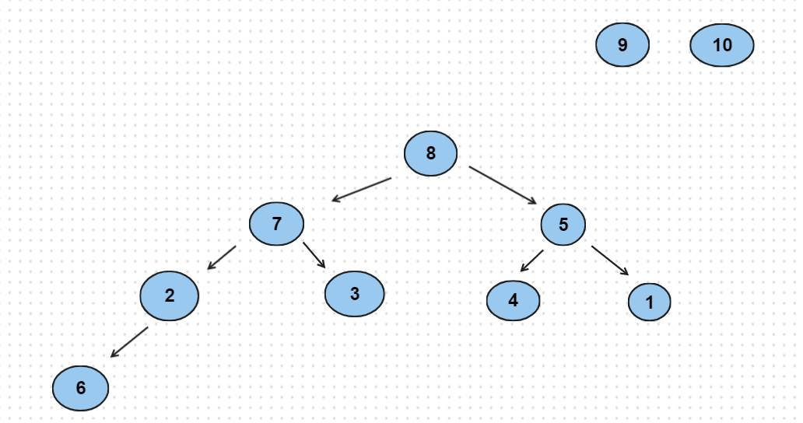

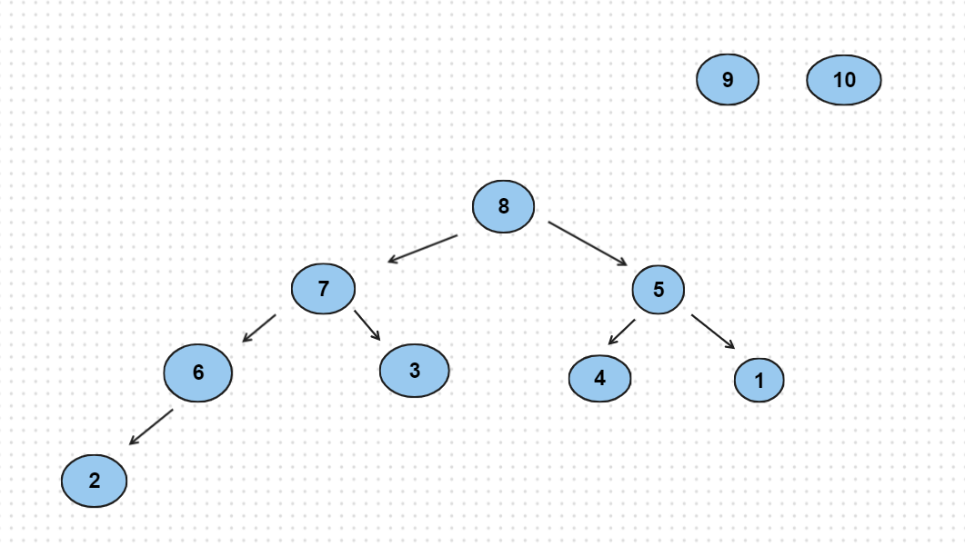

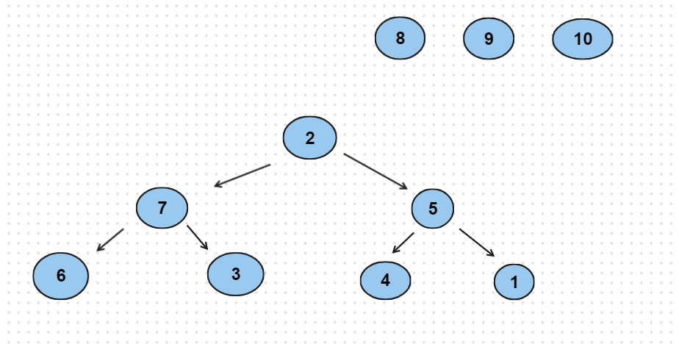

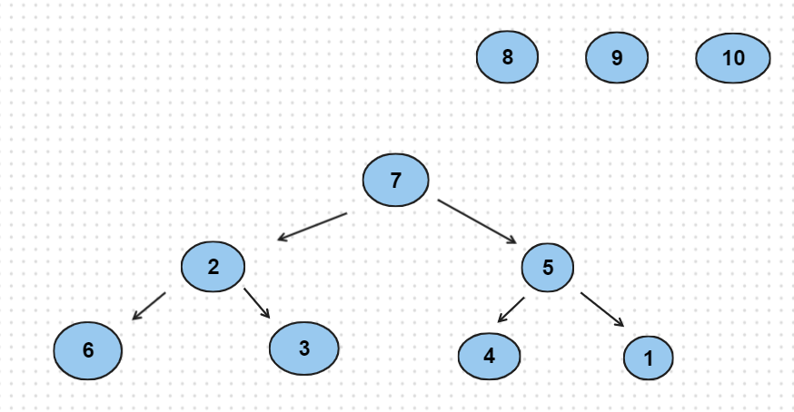

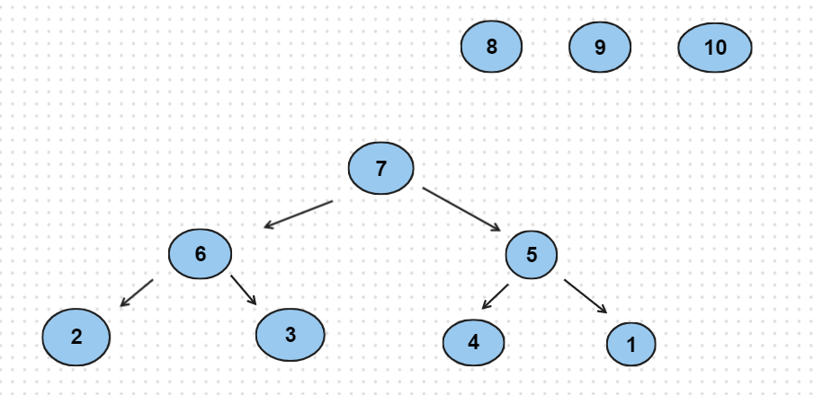

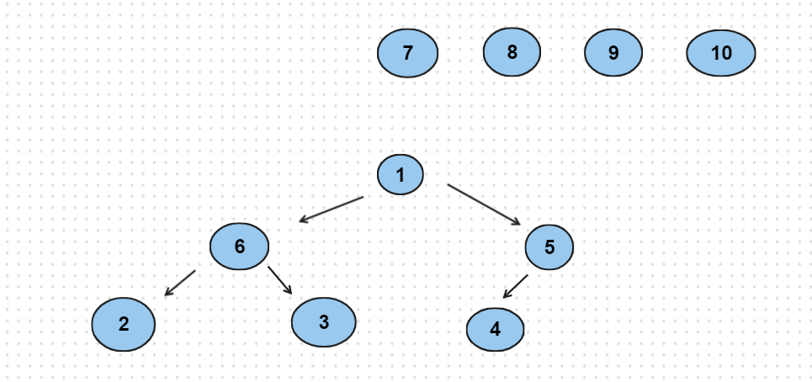

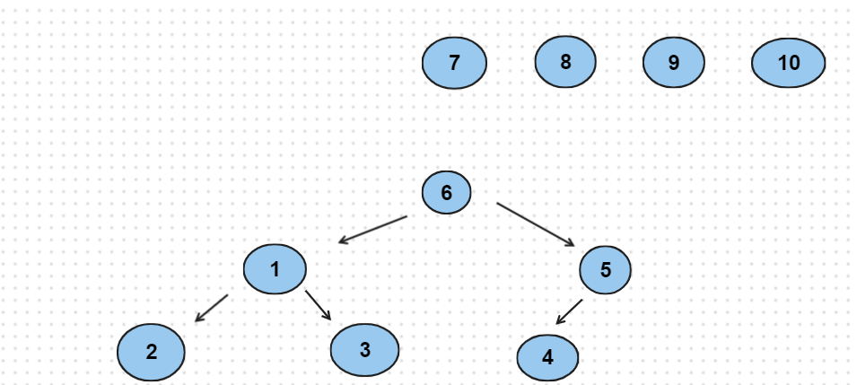

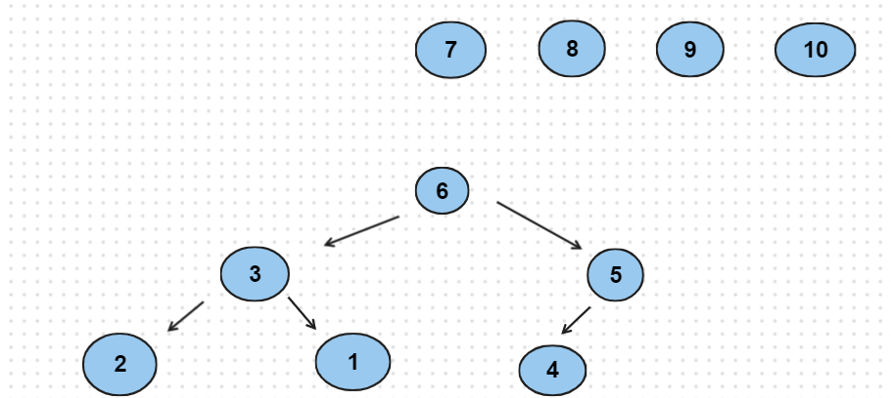

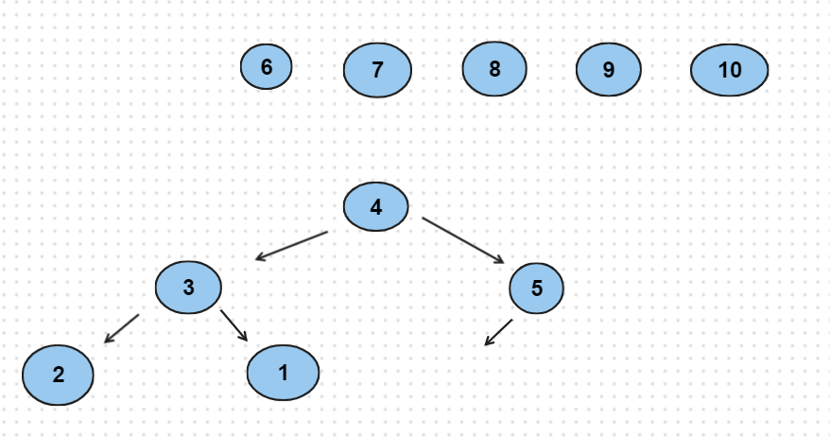

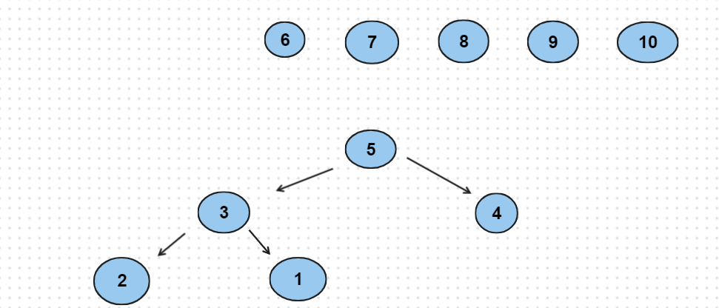

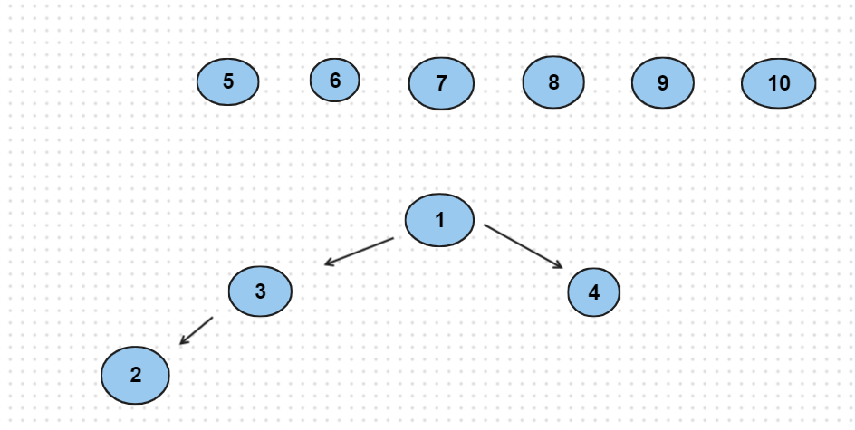

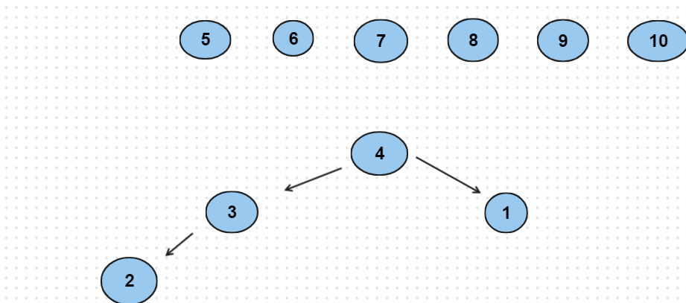

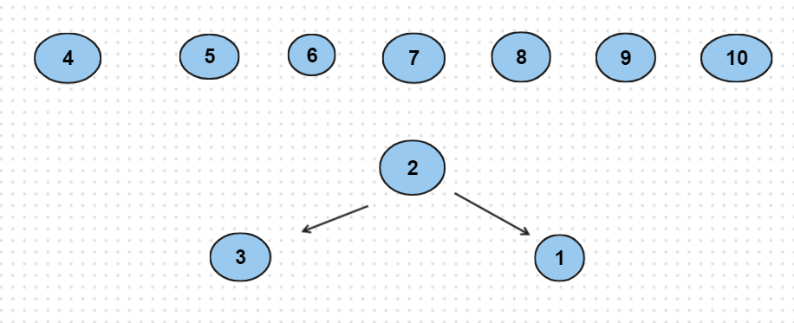

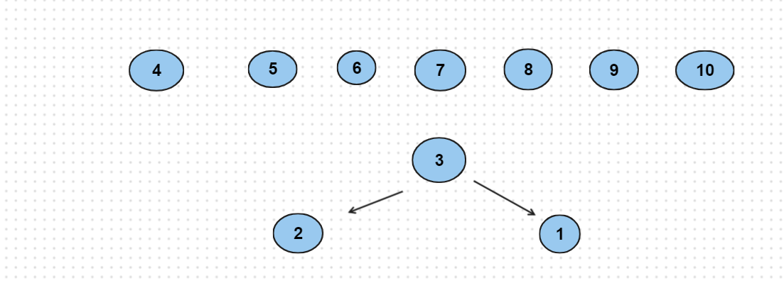

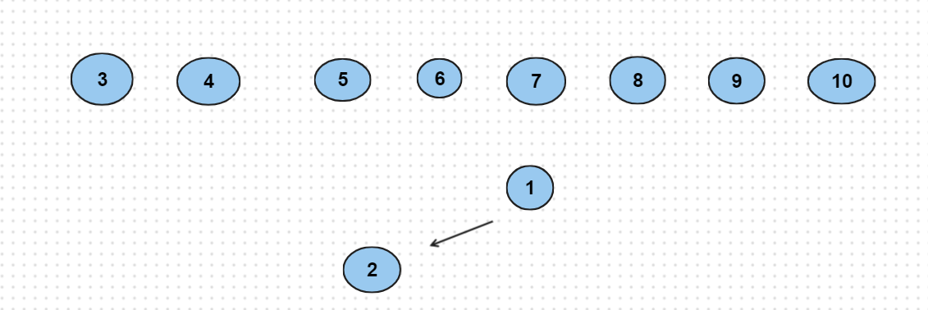

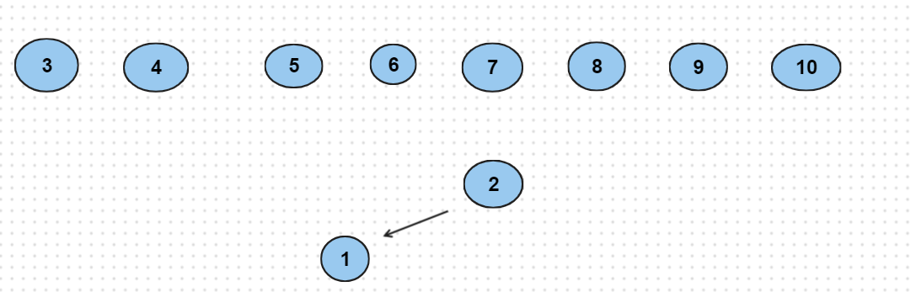

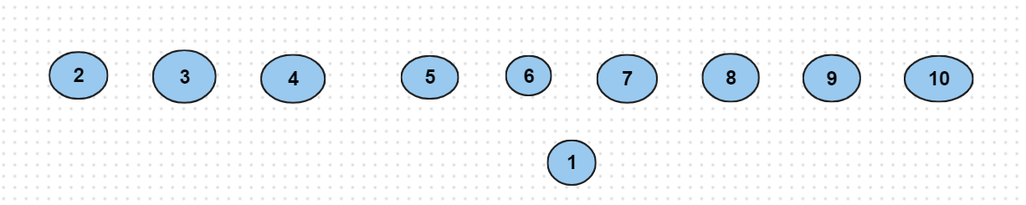

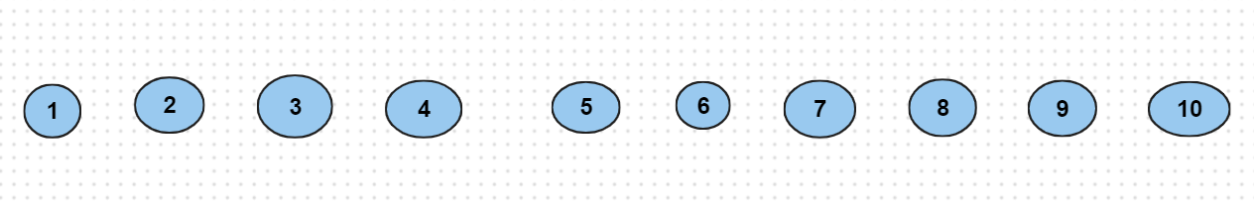

Radix sort: 9, 10, 1, 2, 3, 4, 5, 6, 7, 8

10, 1, 2, 3, 4, 5, 6, 7, 8, 9

1, 2, 3, 4, 5, 6, 7, 8, 9, 10

* 3, 4, 5, 6, 7, 8, 9, 10, 1, 2

Quick sort:

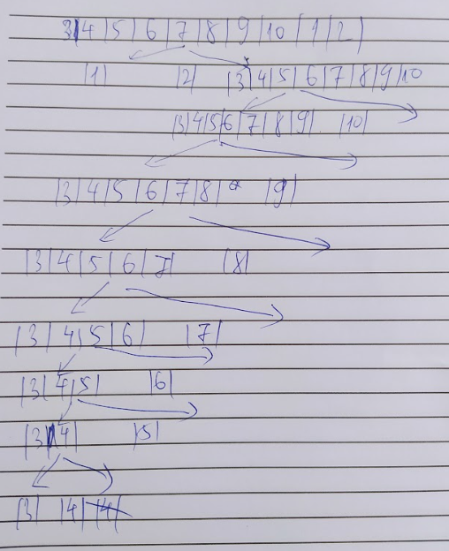

Selection sort:

1, 4, 5, 6, 7, 8, 9, 10, 3, 2

1, 2, 5, 6, 7, 8, 9, 10, 3, 4

1, 2, 3, 6, 7, 8, 9, 10, 5, 4

1, 2, 3, 4, 7, 8, 9, 10, 5, 6

1, 2, 3, 4, 5, 8, 9, 10, 7, 6

1, 2, 3, 4, 5, 6, 9, 10, 7, 8

1, 2, 3, 4, 5, 6, 7, 10, 9, 8

1, 2, 3, 4, 5, 6, 7, 8, 9, 10

Insertion sort: 3, 4, 5, 6, 7, 8, 9, 10, 1, 2

1, 3, 4, 5, 6, 7, 8, 9, 10

1, 2, 3, 4, 5, 6, 7, 8, 9, 10

Bubble sort: 3, 4, 5, 6, 7, 8, 9, 1, 2, 10

4, 5, 6, 7, 8, 9, 1, 2, 3, 10

5, 6, 7, 8, 9, 1, 2, 3, 4, 10

6, 7, 8, 9, 1, 2, 3, 4, 5, 10

7, 8, 9, 1, 2, 3, 4, 5, 6, 10

8, 9, 1, 2, 3, 4, 5, 6, 7, 10

9, 1, 2, 3, 4, 5, 6, 7, 8, 10

1, 2, 3, 4, 5, 6, 7, 8, 9, 10

Merge sort:

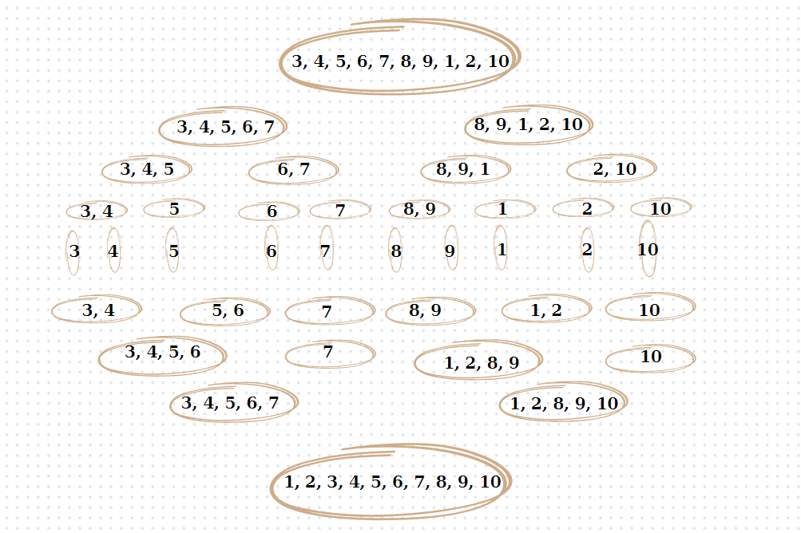

Heap sort:

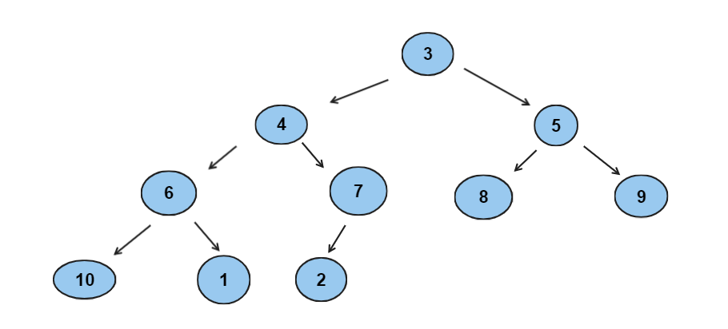

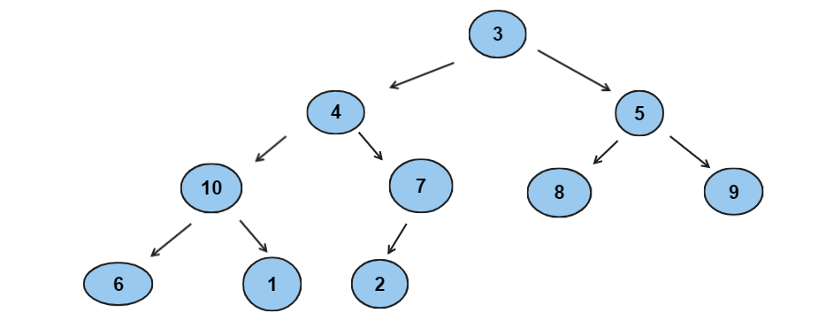

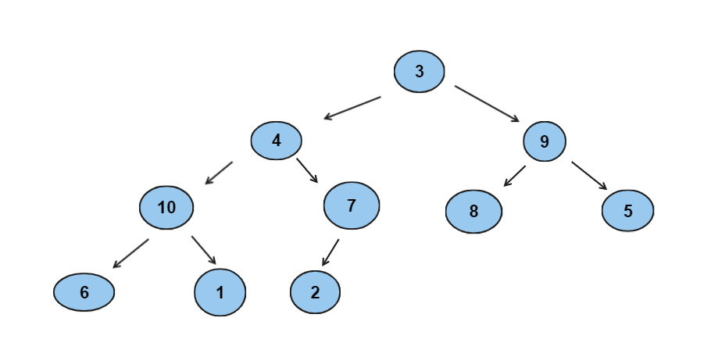

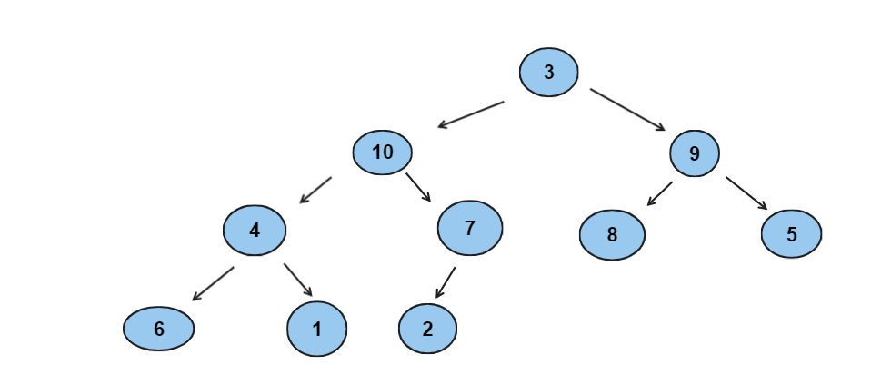

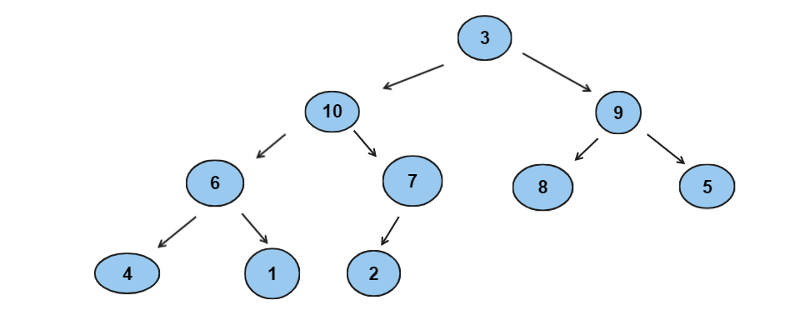

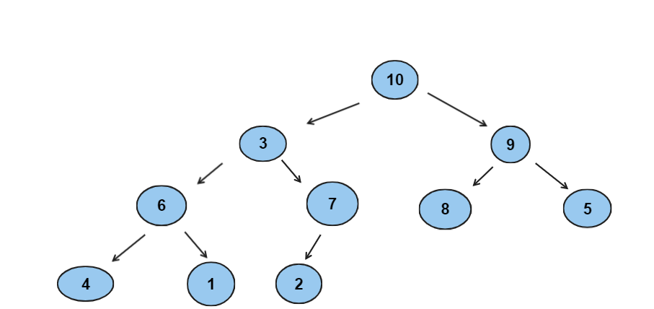

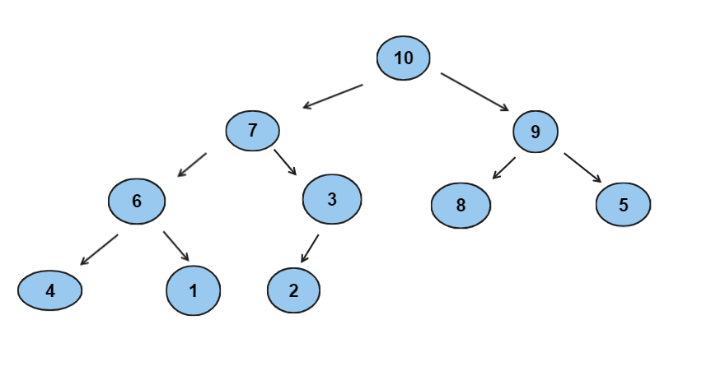

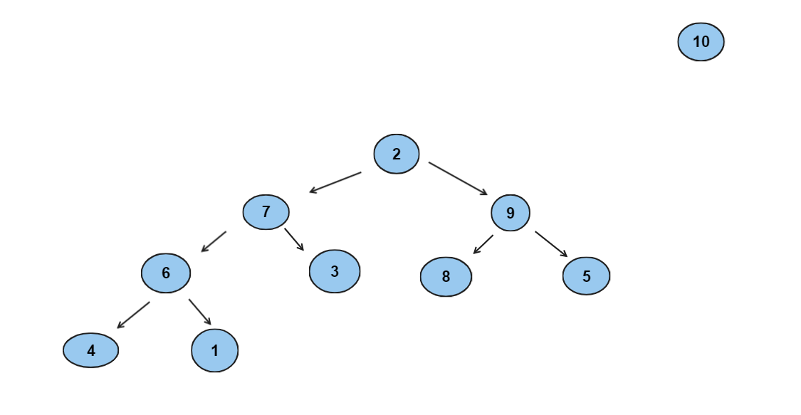

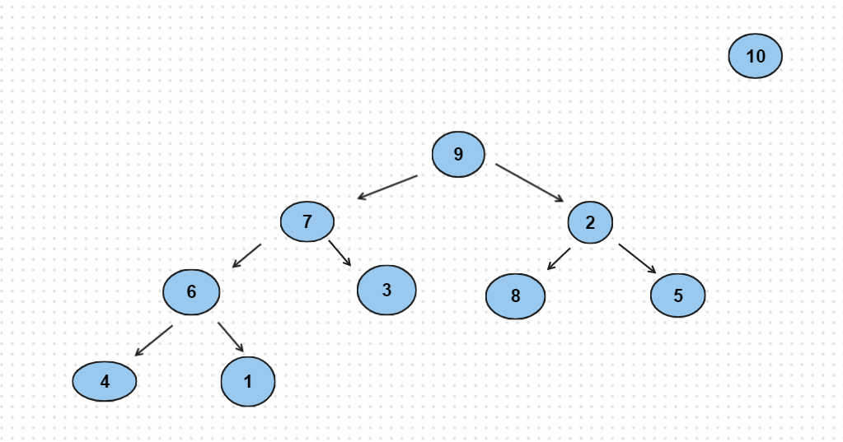

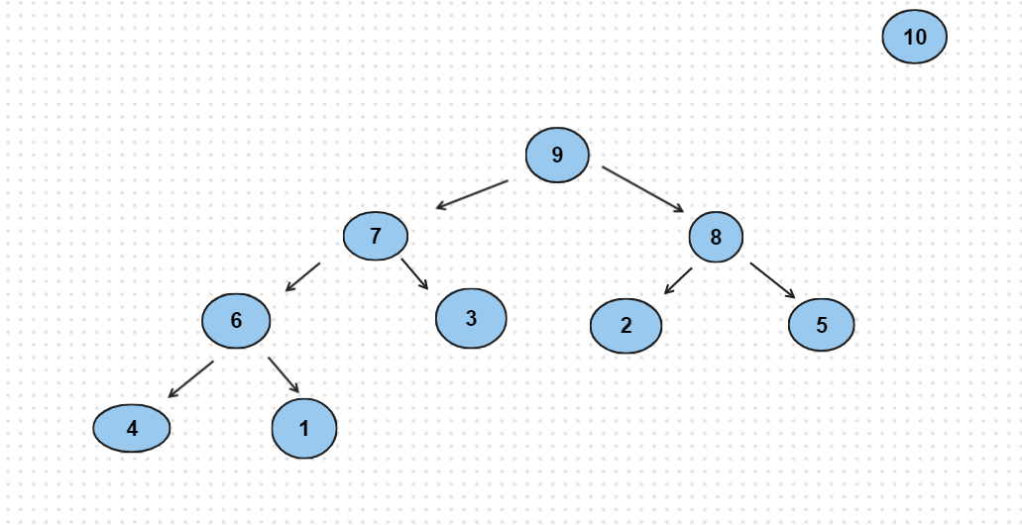

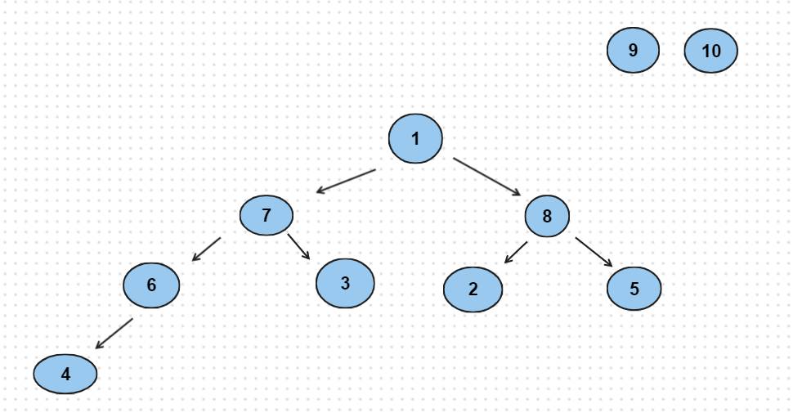

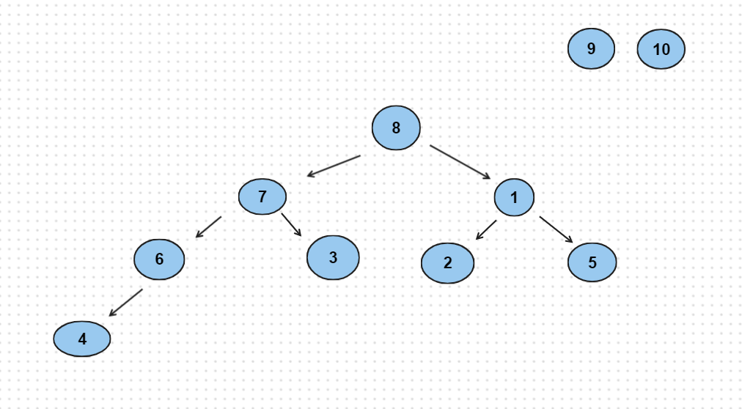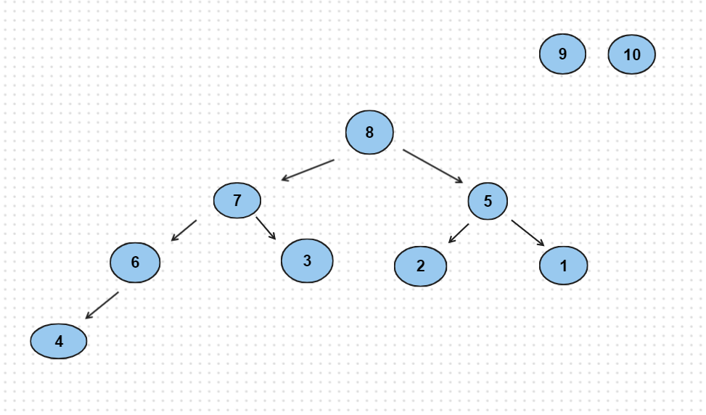

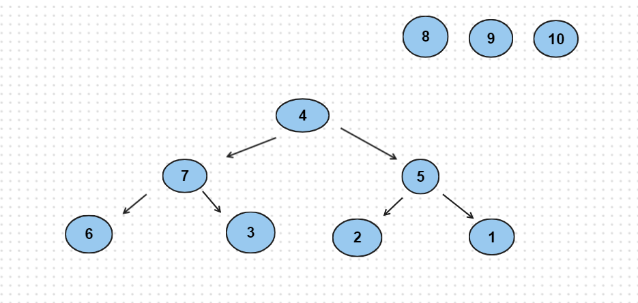

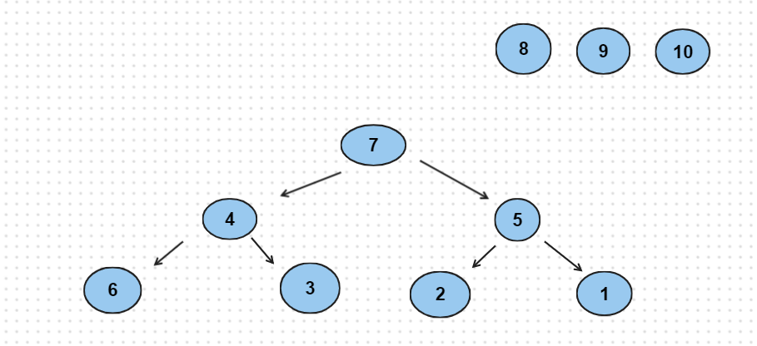

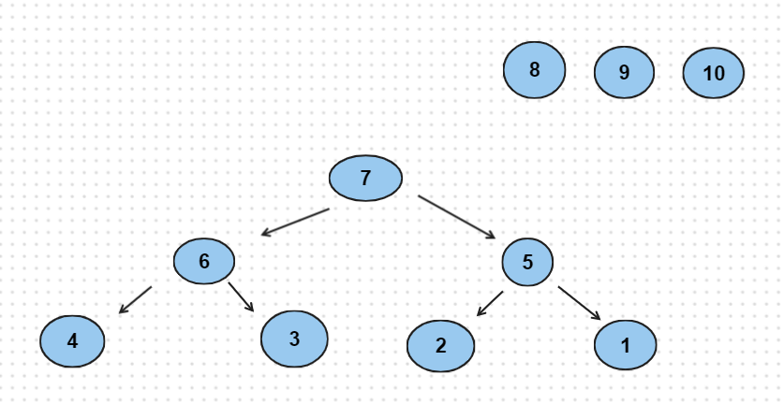

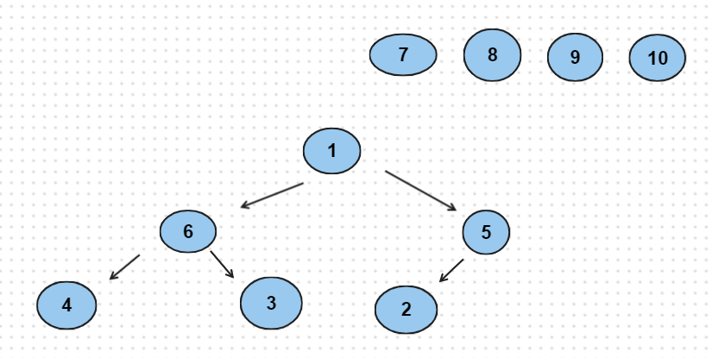

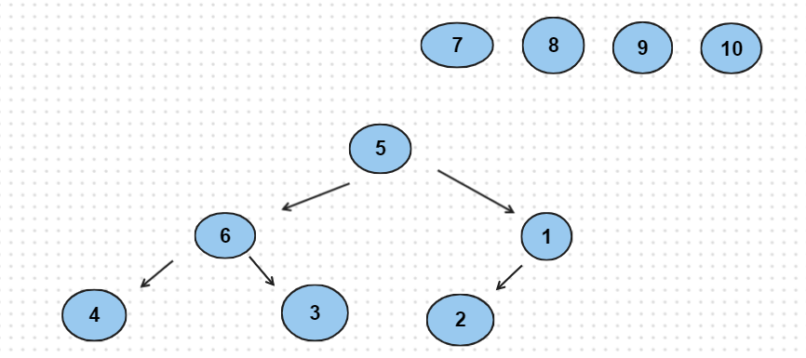

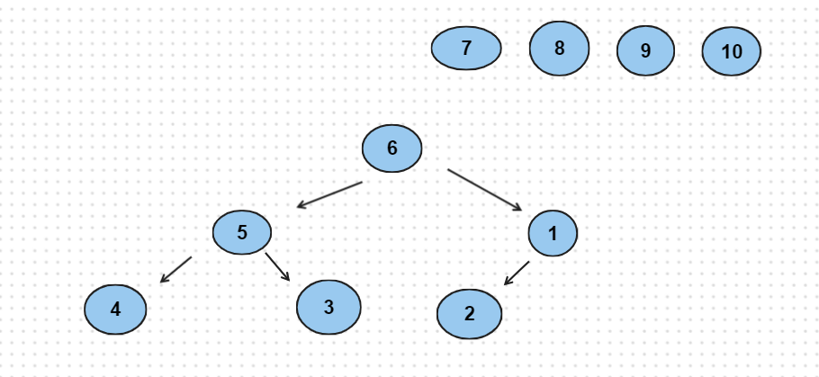

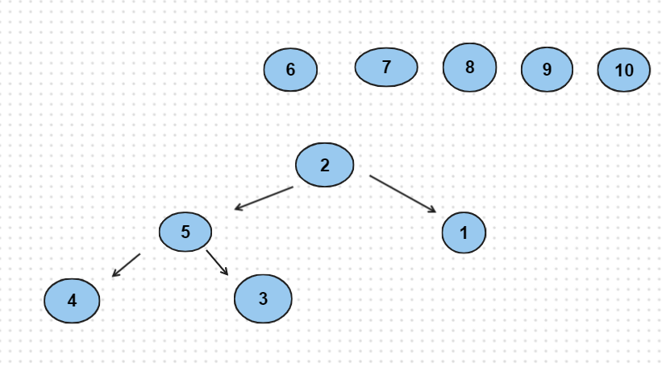

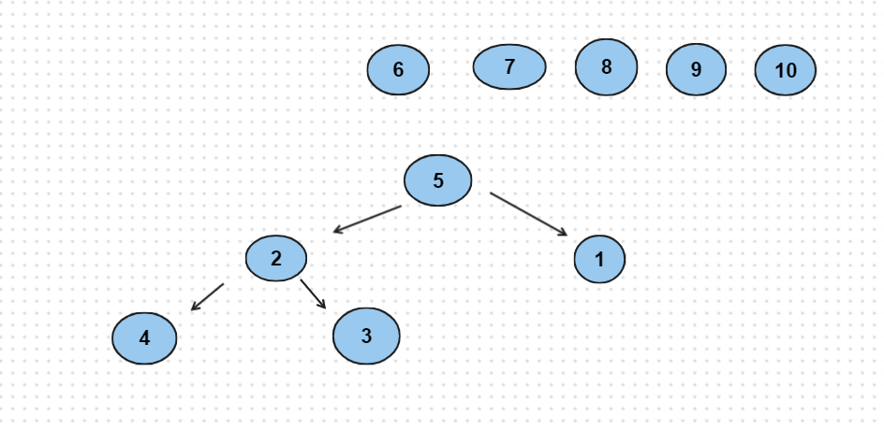

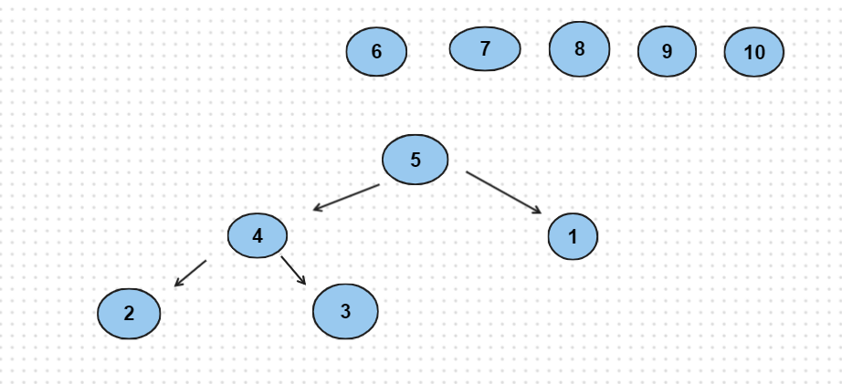

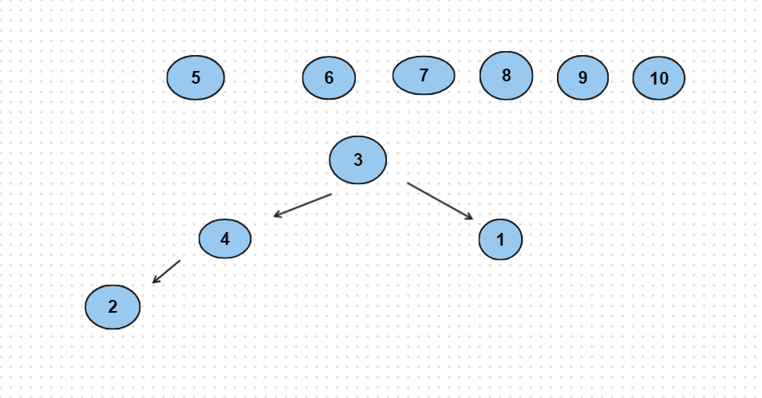

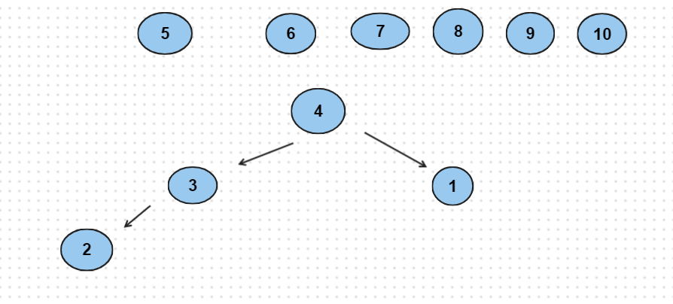

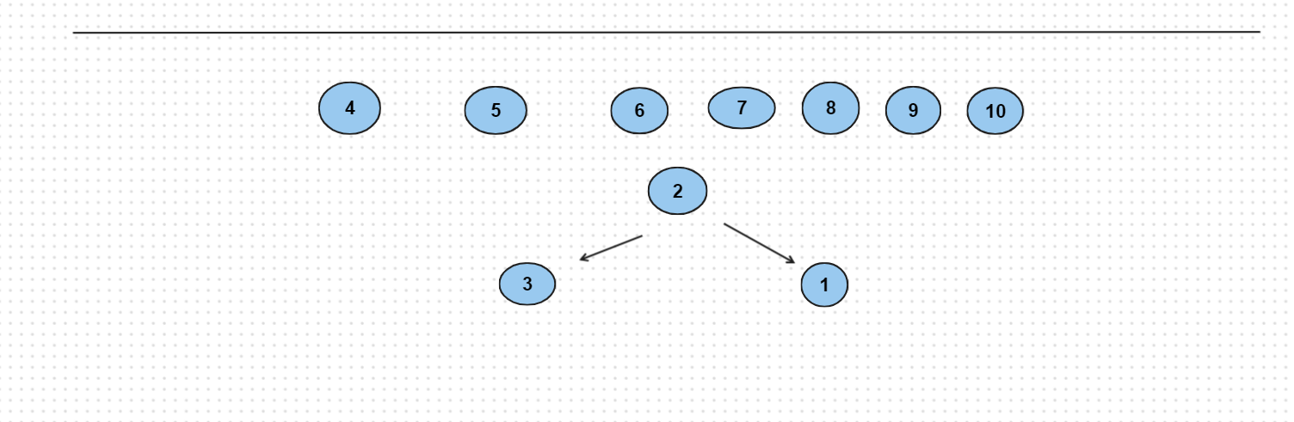

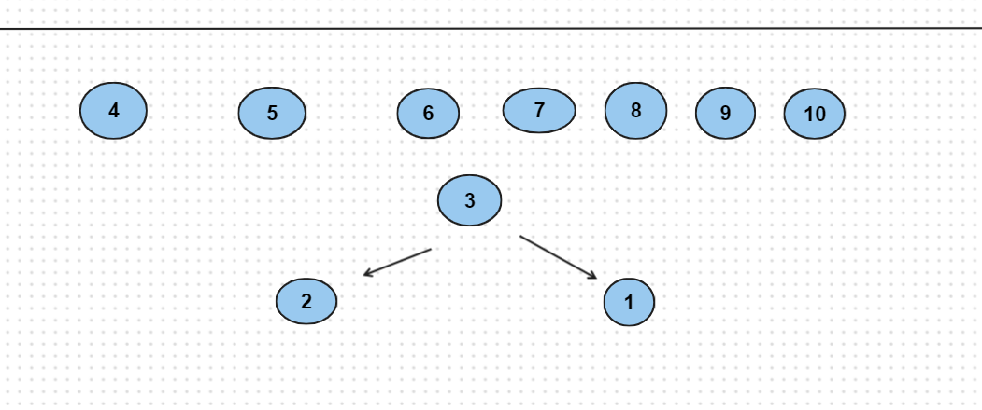

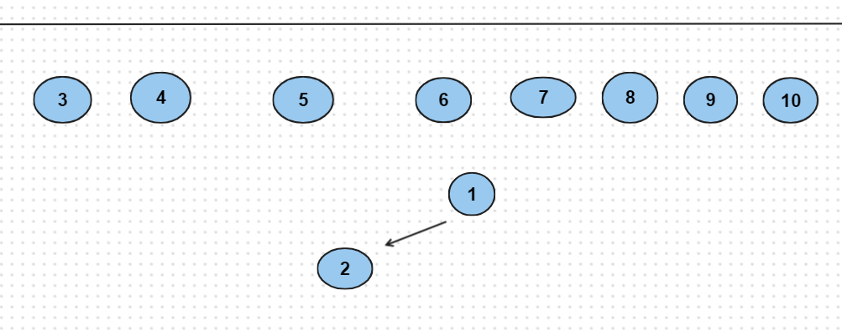

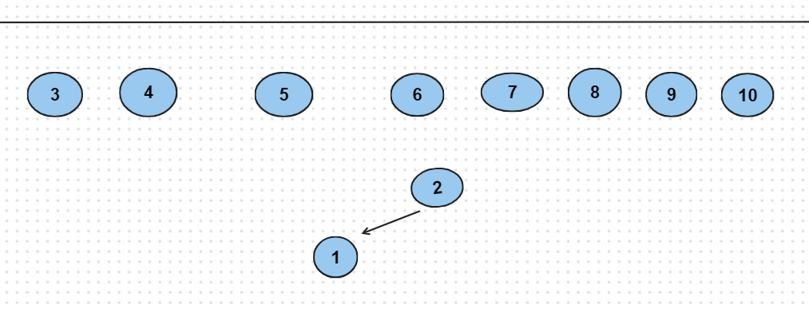

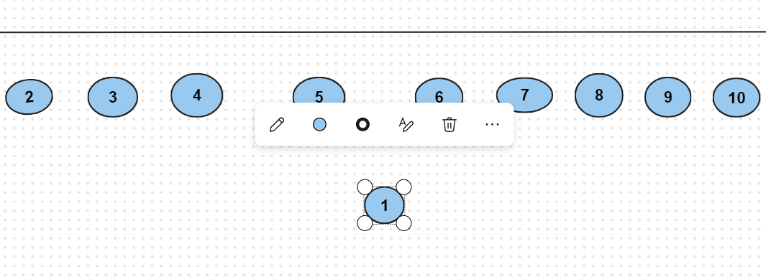

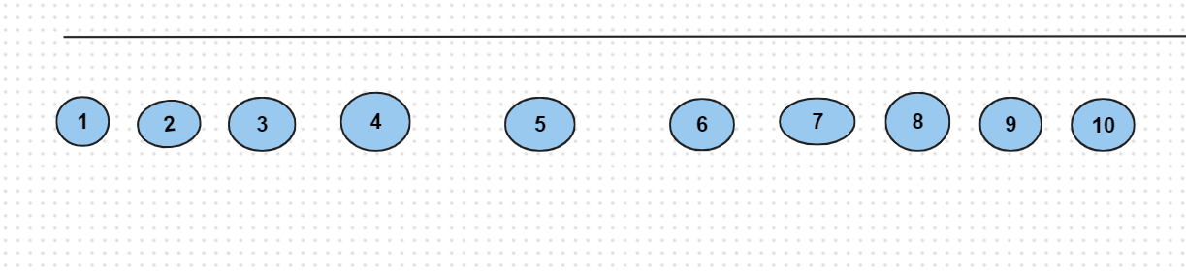

Radix sort: 3, 4, 5, 6, 7, 8, 9, 10, 1, 2

10, 1, 2, 3, 4, 5, 6, 7, 8, 9

1, 2, 3, 4, 5, 6, 7, 8, 9, 10

1. Write a program to sort (ascending sort) the list by following methods:

* Selection sort
* Insertion sort
* Bubble sort
* Merge sort
* Quick sort
* Heap sort
* Radix sort

#include <bits/stdc++.h>

using namespace std;

void selectionSort(int a[], int n){

for (int i = 0; i < n - 1; i++) {

int min_pos = i;

for (int j = i + 1; j < n; j++) {

if (a[j] < a[min_pos]) {

min_pos = j;

}

}

swap(a[i], a[min_pos]);

}

}

void bubbleSort(int a[], int n) {

for (int i = 0; i < n - 1; i++) {

for (int j = 0; j < n - i - 1; j++) {

if (a[j] > a[j + 1]) {

swap(a[j], a[j + 1]);

}

}

}

}

void insertionSort(int a[], int n) {

for (int i = 1; i < n; i++) {

int tmp = a[i], pos = i - 1;

while (pos > 0 && tmp < a[pos]) {

a[pos + 1] = a[pos];

--pos;

}

}

}

//Merge sort

void Merge(int a[], int l, int m, int r) {

vector<int> x(a + l, a + m + 1);

vector<int> y(a + m + 1, a + r + 1);

int i = 0, j = 0;

while (i < s.size() && j < y.size()) {

if (x[i] <= y[j]) {

a[l] = x[i];

++l;

++i;

}

else {

a[l] = y[j];

++l;

++j;

}

}

while (i < x.size()) {

a[l] = x[i];

++l;

++i;

}

while (j < y.size()) {

a[l] = y[j];

++l;

++j;

}

}

void mergeSort(int a[], int l, int r) {

if (l < r) {

int m = (l + r) / 2;

mergeSort(a, l, m);

mergeSort(a, m + 1, r);

Merge(a, l, m, r);

}

}

//quicksort

void part(int a[], int l, int r) {

int pivot = a[r];

int i = l - 1;

for (int j = l; j < r; j++) {

if (a[j] <= pivot) {

++i;

swap(a[i], a[j]);

}

}

++i;

swap(a[i], a[r]);

return i;

}

void quickSort(int a[], int l, int r) {

if (l < r) {

int p = part(a, l, r);

quicksort(a, l, p - 1);

quicksort(a, p + 1; r);

}

}

int main() {

return 0;

}